UNITED STATES
SECURITIES AND EXCHANGE COMMISSION
Washington, D.C. 20549
FORM 8-K
CURRENT REPORT
Pursuant to Section 13 or 15(d)
of the Securities Exchange Act of 1934
Date of Report (Date of earliest event reported): October 22, 2026

SS&C TECHNOLOGIES HOLDINGS, INC.
(Exact name of Registrant as Specified in Its Charter)

Delaware | 001-34675 | 71-0987913
(State or Other Jurisdiction  of Incorporation) | (Commission  File Number) | (IRS Employer  Identification No.)

80 Lamberton Road, Windsor, CT | 06095
(Address of Principal Executive Offices) | (Zip Code)
Registrant’s telephone number, including area code: (860) 298-4500
Not Applicable
(Former Name or Former Address, if Changed Since Last Report)
Check the appropriate box below if the Form 8-K filing is intended to simultaneously satisfy the filing obligation of the registrant under any of the following provisions (see General Instruction A.2. below):

☐ | Written communications pursuant to Rule 425 under the Securities Act (17 CFR 230.425)
☐ | Soliciting material pursuant to Rule 14a-12 under the Exchange Act (17 CFR 240.14a-12)
☐ | Pre-commencement communications pursuant to Rule 14d-2(b) under the Exchange Act (17 CFR 240.14d-2(b))
☐ | Pre-commencement communications pursuant to Rule 13e-4(c) under the Exchange Act (17 CFR 240.13e-4(c))
Indicate by check mark whether the registrant is an emerging growth company as defined in Rule 405 of the Securities Act of 1933 (§230.405 of this chapter) or Rule 12b-2 of the Securities Exchange Act of 1934 (§240.12b-2 of this chapter).
☐ | Emerging growth company
If an emerging growth company, indicate by check mark if the registrant has elected not to use the extended transition period for complying with any new or revised financial accounting standards provided pursuant to Section 13(a) of the Exchange Act. ☐
Securities registered pursuant to Section 12(b) of the Act:
Title of each class | Trading Symbol | Name of each exchange on which registered
Common stock, par value $0.01 per share | SSNC | The Nasdaq Global Select Market

Item 2.02. Results of Operations and Financial Condition
On October 22, 2026, SS&C Technologies Holdings, Inc. (the “Company”) announced its financial results for the quarter ended September 30, 2026. The full text of the press release and earnings release presentation issued in connection with the announcement are furnished as Exhibit 99.1 and Exhibit 99.2, respectively, to this Current Report on Form 8-K.
The information in this Form 8-K (including Exhibits 99.1 and 99.2) shall not be deemed “filed” for purposes of Section 18 of the Securities Exchange Act of 1934 (the “Exchange Act”) or otherwise subject to the liabilities of that section, nor shall it be deemed incorporated by reference in any filing under the Securities Act of 1933 or the Exchange Act, except as expressly set forth by specific reference in such a filing.
Item 9.01. Financial Statements and Exhibits
(d) Exhibits
The following exhibits relating to Item 2.02 shall be deemed to be furnished, and not filed:

99.1 | Press Release, issued by the Company on October 22, 2026.
99.2 | Q3 2026 Earnings Presentation dated October 22, 2026.
104 | The cover page from this Current Report on Form 8-K, formatted in Inline XBRL

SIGNATURE
Pursuant to the requirements of the Securities Exchange Act of 1934, the Registrant has duly caused this report to be signed on its behalf by the undersigned hereunto duly authorized.

 |  | SS&C TECHNOLOGIES HOLDINGS, INC.
Date: October 22, 2026 |  | By: | /s/ Brian N. Schell
 |  |  | Brian N. Schell
 |  |  | Executive Vice President and Chief Financial Officer

Exhibit 99.1

SS&C Technologies Releases Q3 2026 Financial Results

Q3 2026 GAAP revenue $1,690.0 million, up 7.8%, Fully Diluted GAAP Earnings Per Share $0.83
Adjusted revenue $1,691.1 million, up 7.8%, Adjusted Diluted Earnings Per Share $1.78, up 14.8%

WINDSOR, CT, October 22, 2026 (BUSINESS WIRE) -- SS&C Technologies Holdings, Inc. (NASDAQ: SSNC), a global provider of investment, financial and healthcare technology and technology-enabled services, today announced its financial results for the third quarter ended September 30, 2026.

 | Three Months Ended September 30, |  |  | Nine Months Ended September 30,
(in millions, except per share data): | 2026 | 2025 | Change | 2026 | 2025 | Change
GAAP Results
Revenue | $1,690.0 | $1,568.0 | 7.8% | $5,032.8 | $4,618.7 | 9.0%
Operating income | 409.3 | 365.7 | 11.9% | 1,224.6 | 1,068.1 | 14.7%
Operating income margin | 24.2% | 23.3% | 90 bps | 24.3% | 23.1% | 120 bps
Net income | 198.9 | 210.0 | (5.3)% | 659.8 | 603.8 | 9.3%
Diluted earnings per share | $0.83 | $0.83 | — | $2.71 | $2.39 | 13.4%
Adjusted Non-GAAP Results (defined in Notes 1 - 4 below)
Adjusted revenue | $1,691.1 | $1,569.0 | 7.8% | $5,036.2 | $4,621.6 | 9.0%
Adjusted operating income | 657.6 | 602.5 | 9.1% | 1,945.0 | 1,761.3 | 10.4%
Adjusted operating income margin | 38.9% | 38.4% | 50 bps | 38.6% | 38.1% | 50 bps
Adjusted consolidated EBITDA | 674.8 | 619.0 | 9.0% | 1,996.5 | 1,811.3 | 10.2%
Adjusted consolidated EBITDA margin | 39.9% | 39.5% | 40 bps | 39.6% | 39.2% | 40 bps
Adjusted diluted earnings per share(1) | $1.78 | $1.55 | 14.8% | $5.23 | $4.52 | 15.7%
(1) Reflects non-GAAP tax rates of 22.5% for the three and nine months ended September 30, 2026 and 22.0% for the three and nine months ended September 30, 2025. See Note 4 for more information.

Third Quarter 2026 Highlights:

•
Q3 2026 GAAP Revenue growth and Adjusted Revenue growth were 7.8 percent.
•
Q3 2026 Adjusted Organic Revenue Growth was 5.2 percent.
•
Net cash generated from operating activities of $1,216.3 million for the nine months ended September 30, 2026, up 10.4 percent compared to the same period in 2025.
•
Returned $225.3 million to shareholders in Q3 2026, which included 1.9 million shares repurchased for $154.8 million and $70.5 million in common stock dividends.
•
Paid down $130.0 million in debt, bringing our net leverage ratio to 2.63x
•
Record adjusted consolidated EBITDA of $674.8 million for Q3 2026, up 9.0 percent. Adjusted consolidated EBITDA margin for Q3 2026 was 39.9 percent.
•
GAAP operating income margin for Q3 2026 was 24.2 percent and GAAP net income of $198.9 million for Q3 2026.
•
Adjusted diluted earnings per share was $1.78, up 14.8 percent.
•
In August, SS&C increased our common stock dividend to $1.20 annually, an 11.1 percent increase.

"SS&C delivered another quarter of strong results, with Q3 organic revenue growth of 5.2%, record adjusted consolidated EBITDA of $674.8 million, and margins of 39.9%, keeping us on track to achieve our full-year goals," said Bill Stone, Chairman and Chief Executive Officer. "In September, we hosted over 1,000 financial services and healthcare leaders at our annual SS&C Deliver conference, and it was clear that holistic transformation of our clients' operating models is a top priority. As we harness emerging technologies like agentic AI and tokenization, SS&C is evolving in step with our clients—partnering with them, supporting them, and shaping the future together."


1

Operating Cash Flow

SS&C generated net cash from operating activities of $1,216.3 million for the nine months ended September 30, 2026, compared to $1,101.3 million for the same period in 2025, a 10.4% increase. SS&C ended the third quarter with $525.4 million in cash and cash equivalents and $7,483.5 million in gross debt. SS&C’s consolidated net leverage ratio as defined in our credit agreement stood at 2.63 times consolidated EBITDA as of September 30, 2026. SS&C’s net secured leverage ratio stood at 1.59 times consolidated EBITDA as of September 30, 2026.

Guidance
 |  | Q4 2026 |  | FY 2026
Adjusted Revenue ($M) |  | $1,700 – $1,740 |  | $6,736 – $6,776
Adjusted Net Income ($M) |  | $454 – $470 |  | $1,726 – $1,742
Interest Expense1 ($M) |  | $103 – $105 |  | $417 – $419
Adjusted Diluted Earnings per Share |  | $1.88 – $1.94 |  | $7.11 – $7.17
Cash from Operating Activities ($M) |  | – |  | $1,717 – $1,817
Capital Expenditures (% of revenue) |  | – |  | 4.4% – 4.8%
Diluted Shares (M) |  | 240.0 – 243.0 |  | 242.7 – 242.9
Effective Income Tax Rate (%) |  | 21.5% – 23.5% |  | 21.5% – 23.5%

1Interest expense is net of deferred financing cost amortization and original issue discount

SS&C does not provide reconciliations of guidance for Adjusted Revenues and Adjusted Net Income to comparable GAAP measures, in reliance on the unreasonable efforts exception provided under Item 10(e)(1)(i)(B) of Regulation S-K. SS&C is unable, without unreasonable efforts, to forecast certain items required to develop meaningful comparable GAAP financial measures. These items include acquisition transactions and integration, foreign exchange rate changes, as well as other non-cash and other adjustments as defined under the Company’s Credit agreement, that are difficult to predict in advance in order to include in a GAAP estimate. The unavailable information could have a significant impact on Q4 2026 and FY 2026 GAAP financial results.

Non-GAAP Financial Measures

Adjusted revenue, adjusted operating income, adjusted consolidated EBITDA, adjusted net income and adjusted diluted earnings per share are non-GAAP measures. See the accompanying notes for the reconciliations and definitions for each of these non-GAAP measures and the reasons our management believes these measures provide useful information to investors regarding our financial condition and results of operations. All references above to net income, diluted earnings per share, adjusted operating income, adjusted consolidated EBITDA, and adjusted diluted earnings per share are attributable to SS&C.

2

Earnings Call and Press Release
SS&C’s third quarter 2026 earnings call will take place at 5:00 p.m. eastern time today, October 22, 2026. The call will discuss third quarter 2026 results. Interested parties may visit investor.ssctech.com to access the live webcast and view accompanying slides. The call will be available for replay via the webcast on SS&C’s website; access: https://investor.ssctech.com/financials/quarterly-results/default.aspx
Certain information contained in this press release, including information relating to, among other things, the Company’s financial guidance for the fourth quarter and full year of 2026 constitute forward-looking statements for purposes of the safe harbor provisions under the Private Securities Litigation Reform Act of 1995. Forward-looking statements include statements concerning plans, objectives, goals, strategies, expectations, intentions, projections, developments, future events, performance, underlying assumptions, and other statements that are other than statements of historical facts. Without limiting the foregoing, the words “believes”, “anticipates”, “plans”, “expects”, “estimates”, “projects”, “forecasts”, “may”, “assume”, “intend”, “will”, “continue”, “opportunity”, “predict”, “potential”, “future”, “guarantee”, “likely”, “target”, “indicate”, “would”, “could” and “should” and similar expressions are intended to identify forward-looking statements, although not all forward-looking statements are accompanied by such words. Such statements reflect management’s best judgment based on factors currently known but are subject to risks and uncertainties, which could cause actual results to differ materially from those anticipated. Such risks and uncertainties include, but are not limited to, the state of the economy and the financial services industry and other industries in which the Company’s clients operate, the Company’s ability to realize anticipated benefits from its acquisitions, the effect of customer consolidation on demand for the Company’s products and services, the variability of revenue as a result of activity in the securities markets, the focus of the Company’s business on the asset management industry, the ability to retain and attract clients, the intensity of competition with respect to the Company’s products and services, risks from cyber-attacks, breaches of digital security, IT system failures and network disruptions, risks associated with third party providers, fluctuations in the Company’s operating results, terrorist activities and other catastrophic events, risks associated with the Company’s foreign operations, privacy concerns relating to the collection and storage of personal information, evolving regulations and increased scrutiny from regulators, the Company’s ability to protect intellectual property assets and litigation regarding intellectual property rights, delays in product development, investment decisions concerning cash balances, tax risks, risks associated with the Company’s joint ventures, changes in accounting standards, evolving regulation and scrutiny from regulators, the Company’s exposure to litigation and other claims, risks related to the Company’s substantial indebtedness, and the market price of the Company’s stock prevailing from time to time, and the risks discussed in the “Risk Factors” section of the Company’s most recent Annual Report on Form 10-K and Quarterly Report on Form 10-Q, which are on file with the Securities and Exchange Commission and can also be accessed on our website. Such “Risk Factors”, among others, could cause actual results to differ materially from those indicated by forward-looking statements made herein and presented elsewhere by management from time to time. Undue reliance should not be placed on any such forward-looking statements. Forward-looking statements speak only as of the date on which they are made and, except to the extent required by applicable securities laws, we undertake no obligation to update or revise any forward-looking statements.

3

About SS&C Technologies

SS&C is a leading provider of mission-critical, AI-powered technology and services empowering financial services and healthcare organizations to work smarter, faster, and securely. Founded in 1986, SS&C is headquartered in Windsor, Connecticut, and has offices worldwide. More than 23,000 financial services and healthcare organizations, from the world's largest companies to small and mid-market firms, rely on SS&C for expertise, scale and technology.
Follow SS&C on Twitter, LinkedIn and Facebook.
For more information
Brian Schell
Chief Financial Officer
Tel: +1-816-642-0915
E-mail: InvestorRelations@sscinc.com

Justine Stone
Head of Investor Relations
Tel: +1-212-367-4705
E-mail: InvestorRelations@sscinc.com

4

SS&C Technologies Holdings, Inc. and Subsidiaries
Condensed Consolidated Statements of Comprehensive Income
(in millions, except per share data)
(unaudited)

 |  | Three Months Ended September 30, |  |  |  |  |  |  |  | Nine Months Ended September 30,
 |  | 2026 |  |  |  | 2025 |  |  |  | 2026 |  |  |  | 2025
Revenues:
Technology-enabled services |  | $ | 1,448.6 |  |  | $ | 1,309.4 |  |  | $ | 4,264.1 |  |  | $ | 3,847.0
License, maintenance and related |  |  | 241.4 |  |  |  | 258.6 |  |  |  | 768.7 |  |  |  | 771.7
Total revenues |  |  | 1,690.0 |  |  |  | 1,568.0 |  |  |  | 5,032.8 |  |  |  | 4,618.7
Cost of revenues:
Technology-enabled services |  |  | 771.9 |  |  |  | 714.2 |  |  |  | 2,284.0 |  |  |  | 2,075.4
License, maintenance and related |  |  | 104.3 |  |  |  | 106.0 |  |  |  | 314.9 |  |  |  | 311.5
Total cost of revenues |  |  | 876.2 |  |  |  | 820.2 |  |  |  | 2,598.9 |  |  |  | 2,386.9
Gross profit |  |  | 813.8 |  |  |  | 747.8 |  |  |  | 2,433.9 |  |  |  | 2,231.8
Operating expenses:
Selling and marketing |  |  | 154.7 |  |  |  | 144.7 |  |  |  | 466.9 |  |  |  | 449.4
Research and development |  |  | 131.5 |  |  |  | 118.6 |  |  |  | 398.4 |  |  |  | 375.8
General and administrative |  |  | 118.3 |  |  |  | 118.8 |  |  |  | 344.0 |  |  |  | 338.5
Total operating expenses |  |  | 404.5 |  |  |  | 382.1 |  |  |  | 1,209.3 |  |  |  | 1,163.7
Operating income |  |  | 409.3 |  |  |  | 365.7 |  |  |  | 1,224.6 |  |  |  | 1,068.1
Interest expense, net |  |  | (107.2 | ) |  |  | (104.2 | ) |  |  | (319.6 | ) |  |  | (314.9 | )
Other income, net |  |  | 2.9 |  |  |  | 5.3 |  |  |  | 10.8 |  |  |  | 11.4
Equity in earnings of unconsolidated affiliates, net |  |  | (47.7 | ) |  |  | (11.6 | ) |  |  | (40.8 | ) |  |  | (7.7 | )
Loss on extinguishment of debt |  |  | (0.6 | ) |  |  | (1.3 | ) |  |  | (1.0 | ) |  |  | (2.2 | )
Income before income taxes |  |  | 256.7 |  |  |  | 253.9 |  |  |  | 874.0 |  |  |  | 754.7
Provision for income taxes |  |  | 58.6 |  |  |  | 43.5 |  |  |  | 214.3 |  |  |  | 150.0
Net income |  |  | 198.1 |  |  |  | 210.4 |  |  |  | 659.7 |  |  |  | 604.7
Net loss (income) attributable to noncontrolling interest |  |  | 0.8 |  |  |  | (0.4 | ) |  |  | 0.1 |  |  |  | (0.9 | )
Net income attributable to SS&C common stockholders |  | $ | 198.9 |  |  | $ | 210.0 |  |  | $ | 659.8 |  |  | $ | 603.8
Basic earnings per share attributable to SS&C common stockholders |  | $ | 0.85 |  |  | $ | 0.86 |  |  | $ | 2.77 |  |  | $ | 2.47
Diluted earnings per share attributable to SS&C common stockholders |  | $ | 0.83 |  |  | $ | 0.83 |  |  | $ | 2.71 |  |  | $ | 2.39
Basic weighted-average number of common shares outstanding |  |  | 234.6 |  |  |  | 243.8 |  |  |  | 238.0 |  |  |  | 244.8
Diluted weighted-average number of common and common equivalent shares outstanding |  |  | 240.6 |  |  |  | 252.6 |  |  |  | 243.3 |  |  |  | 253.1
Net income |  | $ | 198.1 |  |  | $ | 210.4 |  |  | $ | 659.7 |  |  | $ | 604.7
Other comprehensive (loss) income, net of tax:
Foreign currency exchange translation adjustment |  |  | (6.4 | ) |  |  | (66.4 | ) |  |  | (81.1 | ) |  |  | 233.9
Change in defined benefit pension obligation |  |  | 0.2 |  |  |  | — |  |  |  | 0.4 |  |  |  | —
Total other comprehensive (loss) income, net of tax |  |  | (6.2 | ) |  |  | (66.4 | ) |  |  | (80.7 | ) |  |  | 233.9
Comprehensive income |  |  | 191.9 |  |  |  | 144.0 |  |  |  | 579.0 |  |  |  | 838.6
Comprehensive loss (income) attributable to noncontrolling interest |  |  | 0.8 |  |  |  | (0.4 | ) |  |  | 0.1 |  |  |  | (0.9 | )
Comprehensive income attributable to SS&C common stockholders |  | $ | 192.7 |  |  | $ | 143.6 |  |  | $ | 579.1 |  |  | $ | 837.7

5

SS&C Technologies Holdings, Inc. and Subsidiaries
Condensed Consolidated Balance Sheets
(in millions)
(unaudited)

 |  | September 30, |  |  |  | December 31,
 |  | 2026 |  |  |  | 2025
Assets
Current assets:
Cash and cash equivalents |  | $ | 525.4 |  |  | $ | 462.1
Funds receivable and funds held on behalf of clients |  |  | 3,846.5 |  |  |  | 3,799.5
Accounts receivable, net |  |  | 1,033.7 |  |  |  | 978.7
Contract asset |  |  | 57.4 |  |  |  | 49.2
Prepaid expenses and other current assets |  |  | 183.4 |  |  |  | 193.7
Restricted cash |  |  | 2.5 |  |  |  | 4.5
Total current assets |  |  | 5,648.9 |  |  |  | 5,487.7
Property, plant and equipment, net |  |  | 280.3 |  |  |  | 289.5
Operating lease right-of-use assets |  |  | 217.9 |  |  |  | 233.3
Investments |  |  | 171.3 |  |  |  | 174.4
Unconsolidated affiliates |  |  | 247.3 |  |  |  | 307.7
Contract asset |  |  | 140.2 |  |  |  | 133.1
Goodwill |  |  | 9,928.1 |  |  |  | 9,991.3
Intangible and other assets, net |  |  | 3,781.2 |  |  |  | 4,094.7
Total assets |  | $ | 20,415.2 |  |  | $ | 20,711.7
Liabilities and Equity
Current liabilities:
Current portion of long-term debt (1) |  | $ | 2,260.0 |  |  | $ | 25.0
Client funds obligations |  |  | 3,846.5 |  |  |  | 3,799.5
Accounts payable |  |  | 71.7 |  |  |  | 87.2
Income taxes payable |  |  | — |  |  |  | 23.3
Accrued employee compensation and benefits |  |  | 288.1 |  |  |  | 348.9
Interest payable |  |  | 16.7 |  |  |  | 31.6
Other accrued expenses |  |  | 278.2 |  |  |  | 303.4
Deferred revenue |  |  | 444.7 |  |  |  | 492.4
Total current liabilities |  |  | 7,205.9 |  |  |  | 5,111.3
Long-term debt, net of current portion |  |  | 5,189.5 |  |  |  | 7,408.4
Operating lease liabilities |  |  | 205.4 |  |  |  | 213.2
Other long-term liabilities |  |  | 198.4 |  |  |  | 190.2
Deferred income taxes |  |  | 848.3 |  |  |  | 846.8
Total liabilities |  |  | 13,647.5 |  |  |  | 13,769.9
SS&C stockholders' equity |  |  | 6,698.7 |  |  |  | 6,887.6
Noncontrolling interest |  |  | 69.0 |  |  |  | 54.2
Total equity |  |  | 6,767.7 |  |  |  | 6,941.8
Total liabilities and equity |  | $ | 20,415.2 |  |  | $ | 20,711.7

(1) $2.0 billion of Senior Notes has been classified as current given the stated maturity of September 30, 2027. We are actively addressing this maturity and believe refinancing the Senior Notes is probable of occurring during the 4th quarter of 2026.
6

SS&C Technologies Holdings, Inc. and Subsidiaries
Condensed Consolidated Statements of Cash Flows
(in millions)
(unaudited)

 |  | Nine Months Ended September 30,
 |  | 2026 |  |  |  | 2025
Cash flow from operating activities:
Net income |  | $ | 659.7 |  |  | $ | 604.7
Adjustments to reconcile net income to net cash provided by operating activities:
Depreciation and amortization |  |  | 544.7 |  |  |  | 521.1
Equity in earnings of unconsolidated affiliates, net |  |  | 40.8 |  |  |  | 7.7
Distributions received from unconsolidated affiliates |  |  | 16.9 |  |  |  | —
Stock-based compensation expense |  |  | 185.8 |  |  |  | 172.9
Unrealized net losses on investments |  |  | 2.2 |  |  |  | 2.4
Amortization of debt financing costs |  |  | 5.5 |  |  |  | 4.9
Loss on extinguishment of debt |  |  | 1.0 |  |  |  | 2.2
Loss on sale or disposition of property and equipment |  |  | 2.0 |  |  |  | 0.5
Deferred income taxes |  |  | 1.3 |  |  |  | 46.8
Provision for credit losses |  |  | 15.0 |  |  |  | 12.0
Changes in operating assets and liabilities, excluding effects from acquisitions:
Accounts receivable |  |  | (73.3 | ) |  |  | (54.5 | )
Prepaid expenses and other assets |  |  | (14.6 | ) |  |  | 22.0
Contract assets |  |  | (15.0 | ) |  |  | (29.1 | )
Accounts payable |  |  | (31.5 | ) |  |  | (16.7 | )
Accrued expenses and other liabilities |  |  | (72.6 | ) |  |  | (48.1 | )
Income taxes prepaid and payable |  |  | (0.3 | ) |  |  | (98.8 | )
Deferred revenue |  |  | (51.3 | ) |  |  | (48.7 | )
Net cash provided by operating activities |  |  | 1,216.3 |  |  |  | 1,101.3
Cash flow from investing activities:
Business acquisitions, net of cash acquired |  |  | (0.2 | ) |  |  | (5.9 | )
Additions to property and equipment |  |  | (37.0 | ) |  |  | (70.3 | )
Proceeds from sale of property and equipment |  |  | 2.2 |  |  |  | 5.7
Additions to capitalized software |  |  | (190.2 | ) |  |  | (155.5 | )
Investments in securities |  |  | (7.5 | ) |  |  | (2.5 | )
Proceeds from sales / maturities of investments |  |  | 7.7 |  |  |  | 0.8
Distributions received from (contributions to) unconsolidated affiliates |  |  | 2.6 |  |  |  | (9.8 | )
Collection of other non-current receivables |  |  | 8.1 |  |  |  | 7.9
Net cash used in investing activities |  |  | (214.3 | ) |  |  | (229.6 | )
Cash flow from financing activities:
Cash received from debt borrowings |  |  | 450.0 |  |  |  | 122.0
Repayments of debt |  |  | (440.0 | ) |  |  | (545.1 | )
Net (decrease) increase in client funds obligations |  |  | (323.3 | ) |  |  | 269.4
Proceeds from exercise of stock options |  |  | 86.0 |  |  |  | 362.4
Withholding taxes paid related to equity award net share settlement |  |  | (81.7 | ) |  |  | (73.2 | )
Purchases of common stock for treasury |  |  | (760.5 | ) |  |  | (717.3 | )
Dividends paid on common stock |  |  | (199.8 | ) |  |  | (188.3 | )
Proceeds from (distributions to) noncontrolling interests |  |  | 14.9 |  |  |  | (21.8 | )
Net cash used in financing activities |  |  | (1,254.4 | ) |  |  | (791.9 | )
Effect of exchange rate changes on cash, cash equivalents and restricted cash |  |  | (9.6 | ) |  |  | 9.8
Net (decrease) increase in cash, cash equivalents and restricted cash |  |  | (262.0 | ) |  |  | 89.6
Cash, cash equivalents and restricted cash and cash equivalents, beginning of period |  |  | 3,573.8 |  |  |  | 3,370.5
Cash, cash equivalents and restricted cash and cash equivalents, end of period |  | $ | 3,311.8 |  |  | $ | 3,460.1
Reconciliation of cash, cash equivalents and restricted cash and cash equivalents:
Cash and cash equivalents |  | $ | 525.4 |  |  | $ | 388.3
Restricted cash and cash equivalents |  |  | 2.5 |  |  |  | 2.5
Restricted cash and cash equivalents included in funds receivable and funds held on behalf of clients |  |  | 2,783.9 |  |  |  | 3,069.3
 |  | $ | 3,311.8 |  |  | $ | 3,460.1

7

SS&C Technologies Holdings, Inc. and Subsidiaries
Disclosures Relating to Non-GAAP Financial Measures
Note 1. Reconciliation of Revenues to Adjusted Revenues
Adjusted revenues represents revenues adjusted to include a) amounts that would have been recognized if deferred revenue were not adjusted to fair value at the date of acquisition and b) amounts that would have been recognized if not for adjustments to deferred revenue and retained earnings related to the adoption of ASC 606. Adjusted revenues is presented because we use this measure to evaluate performance of our business against prior periods and believe it is a useful indicator of the underlying performance of our business. Adjusted revenues is not a recognized term under generally accepted accounting principles (“GAAP”). Adjusted revenues does not represent revenues, as that term is defined under GAAP, and should not be considered as an alternative to revenues as an indicator of our operating performance. Adjusted revenues as presented herein is not necessarily comparable to similarly titled measures presented by other companies. Below is a reconciliation of adjusted revenues to revenues, the GAAP measure we believe to be most directly comparable to adjusted revenues.

 |  | Three Months Ended September 30, |  |  |  |  |  |  |  | Nine Months Ended September 30,
(in millions) |  | 2026 |  |  |  | 2025 |  |  |  | 2026 |  |  |  | 2025
Revenues |  | $ | 1,690.0 |  |  | $ | 1,568.0 |  |  | $ | 5,032.8 |  |  | $ | 4,618.7
Purchase accounting adjustments impact on revenue |  |  | 1.1 |  |  |  | 1.0 |  |  |  | 3.4 |  |  |  | 2.9
Adjusted revenues |  | $ | 1,691.1 |  |  | $ | 1,569.0 |  |  | $ | 5,036.2 |  |  | $ | 4,621.6

The following is a breakdown of technology-enabled services and license, maintenance and related revenues and adjusted technology-enabled services and license, maintenance and related revenues.

 |  | Three Months Ended September 30, |  |  |  |  |  |  |  | Nine Months Ended September 30,
(in millions) |  | 2026 |  |  |  | 2025 |  |  |  | 2026 |  |  |  | 2025
Technology-enabled services |  | $ | 1,448.6 |  |  | $ | 1,309.4 |  |  | $ | 4,264.1 |  |  | $ | 3,847.0
License, maintenance and related |  |  | 241.4 |  |  |  | 258.6 |  |  |  | 768.7 |  |  |  | 771.7
Total revenues |  | $ | 1,690.0 |  |  | $ | 1,568.0 |  |  | $ | 5,032.8 |  |  | $ | 4,618.7
Technology-enabled services |  | $ | 1,449.8 |  |  | $ | 1,310.4 |  |  | $ | 4,267.6 |  |  | $ | 3,849.9
License, maintenance and related |  |  | 241.3 |  |  |  | 258.6 |  |  |  | 768.6 |  |  |  | 771.7
Total adjusted revenues |  | $ | 1,691.1 |  |  | $ | 1,569.0 |  |  | $ | 5,036.2 |  |  | $ | 4,621.6

8

Note 2. Reconciliation of Operating Income to Adjusted Operating Income
Adjusted operating income represents operating income adjusted for amortization of intangible assets, stock-based compensation, purchase accounting adjustments for deferred revenue and related costs, ASC 606 adoption impact and other expenses. Adjusted operating income is presented because we use this measure to evaluate performance of our business and believe it is a useful indicator of our underlying performance. Adjusted operating income is not a recognized term under GAAP. Adjusted operating income does not represent operating income, as that term is defined under GAAP, and should not be considered as an alternative to operating income as an indicator of our operating performance. Adjusted operating income as presented herein is not necessarily comparable to similarly titled measures by other companies. The following is a reconciliation between adjusted operating income and operating income, the GAAP measure we believe to be most directly comparable to adjusted operating income.

 |  | Three Months Ended September 30, |  |  |  |  |  |  |  | Nine Months Ended September 30,
(in millions) |  | 2026 |  |  |  | 2025 |  |  |  | 2026 |  |  |  | 2025
Operating income |  | $ | 409.3 |  |  | $ | 365.7 |  |  | $ | 1,224.6 |  |  | $ | 1,068.1
Amortization of intangible assets |  |  | 165.1 |  |  |  | 157.8 |  |  |  | 491.3 |  |  |  | 467.8
Stock-based compensation |  |  | 62.1 |  |  |  | 60.0 |  |  |  | 185.8 |  |  |  | 172.9
Acquisition related |  |  | 0.3 |  |  |  | 3.1 |  |  |  | 1.8 |  |  |  | 6.1
Facilities and workforce restructuring |  |  | 13.8 |  |  |  | 12.0 |  |  |  | 32.4 |  |  |  | 36.2
Other (1) |  |  | 8.9 |  |  |  | 4.3 |  |  |  | 13.8 |  |  |  | 12.6
Adjusted operating income |  | $ | 659.5 |  |  | $ | 602.9 |  |  | $ | 1,949.7 |  |  | $ | 1,763.7
Adjusted operating income attributable to noncontrolling interest (2) |  |  | (1.9 | ) |  |  | (0.4 | ) |  |  | (4.7 | ) |  |  | (2.4 | )
Adjusted operating income attributable to SS&C common stockholders |  | $ | 657.6 |  |  | $ | 602.5 |  |  | $ | 1,945.0 |  |  | $ | 1,761.3

(1)
Other includes additional expenses and income that are permitted to be excluded per the terms of our Credit Agreement from Consolidated EBITDA, a financial measure used in calculating our covenant compliance.
(2)
Adjusted operating income attributable to noncontrolling interest represents the proportionate share of adjusted operating income of DomaniRx, LLC (a consolidated joint venture) retained by our joint venture partners.

9

Note 3. Reconciliation of Net Income to EBITDA, Consolidated EBITDA and Adjusted Consolidated EBITDA
EBITDA represents net income before interest expense, income taxes, depreciation and amortization. Consolidated EBITDA, defined under our Credit Agreement entered into in April 2018, as amended, is used in calculating covenant compliance, and is EBITDA adjusted for certain items. Consolidated EBITDA is calculated by subtracting from or adding to EBITDA items of income or expense described below. Adjusted Consolidated EBITDA is calculated by subtracting acquired EBITDA (as defined below) from Consolidated EBITDA. EBITDA, Consolidated EBITDA and Adjusted Consolidated EBITDA are presented because we use these measures to evaluate performance of our business and believe them to be useful indicators of an entity’s debt capacity and its ability to service debt. EBITDA, Consolidated EBITDA and Adjusted Consolidated EBITDA are not recognized terms under GAAP and should not be considered in isolation or as alternatives to operating income, net income or cash flows from operating activities as indicators of our operating performance. These measures are not necessarily comparable to similarly titled measures by other companies. The following is a reconciliation of EBITDA, Consolidated EBITDA and Adjusted Consolidated EBITDA to net income.

 |  | Three Months Ended September 30, |  |  |  |  |  |  |  | Nine Months Ended September 30, |  |  |  |  |  |  |  | Twelve Months Ended September 30,
(in millions) |  | 2026 |  |  |  | 2025 |  |  |  | 2026 |  |  |  | 2025 |  |  |  | 2026
Net income |  | $ | 198.1 |  |  | $ | 210.4 |  |  | $ | 659.7 |  |  | $ | 604.7 |  |  | $ | 853.7
Interest expense, net |  |  | 107.2 |  |  |  | 104.2 |  |  |  | 319.6 |  |  |  | 314.9 |  |  |  | 430.9
Provision for income taxes |  |  | 58.6 |  |  |  | 43.5 |  |  |  | 214.3 |  |  |  | 150.0 |  |  |  | 240.4
Depreciation and amortization |  |  | 182.8 |  |  |  | 175.4 |  |  |  | 544.7 |  |  |  | 521.1 |  |  |  | 727.3
EBITDA |  |  | 546.7 |  |  |  | 533.5 |  |  |  | 1,738.3 |  |  |  | 1,590.7 |  |  |  | 2,252.3
Stock-based compensation |  |  | 62.1 |  |  |  | 60.0 |  |  |  | 185.8 |  |  |  | 172.9 |  |  |  | 270.5
Acquired EBITDA and cost savings (1) |  |  | — |  |  |  | — |  |  |  | — |  |  |  | — |  |  |  | 2.8
Equity in earnings of unconsolidated affiliates, net |  |  | 47.7 |  |  |  | 11.6 |  |  |  | 40.8 |  |  |  | 7.7 |  |  |  | 42.5
Investment losses (gains) (2) |  |  | 0.6 |  |  |  | (3.3 | ) |  |  | (10.9 | ) |  |  | (13.5 | ) |  |  | (11.4 | )
Facilities and workforce restructuring |  |  | 13.8 |  |  |  | 12.0 |  |  |  | 32.4 |  |  |  | 36.2 |  |  |  | 41.2
Acquisition related |  |  | (2.8 | ) |  |  | 3.8 |  |  |  | (1.3 | ) |  |  | 6.8 |  |  |  | 3.5
Other (3) |  |  | 8.6 |  |  |  | 1.9 |  |  |  | 16.1 |  |  |  | 12.9 |  |  |  | 54.4
Consolidated EBITDA |  | $ | 676.7 |  |  | $ | 619.5 |  |  | $ | 2,001.2 |  |  | $ | 1,813.7 |  |  | $ | 2,655.8
Acquired EBITDA and cost savings (1) |  |  | — |  |  |  | — |  |  |  | — |  |  |  | — |  |  |  | (2.8 | )
Adjusted Consolidated EBITDA |  | $ | 676.7 |  |  | $ | 619.5 |  |  | $ | 2,001.2 |  |  | $ | 1,813.7 |  |  | $ | 2,653.0
Adjusted Consolidated EBITDA attributable to noncontrolling interest (4) |  |  | (1.9 | ) |  |  | (0.5 | ) |  |  | (4.7 | ) |  |  | (2.4 | ) |  |  | (5.5 | )
Adjusted Consolidated EBITDA attributable to SS&C common stockholders |  | $ | 674.8 |  |  | $ | 619.0 |  |  | $ | 1,996.5 |  |  | $ | 1,811.3 |  |  | $ | 2,647.5

(1)
Acquired EBITDA reflects the EBITDA impact of significant businesses that were acquired during the last twelve months as if the acquisition occurred at the beginning of the trailing twelve-month period, as well as cost savings enacted in connection with acquisitions.
(2)
Investment gains includes unrealized fair value adjustments of investments and dividend income received on investments.
(3)
Other includes additional expenses and income that are permitted to be excluded per the terms of our Credit Agreement from Consolidated EBITDA, a financial measure used in calculating our covenant compliance, and includes a loss on the sale of fixed assets of $33.3 million during the twelve months ended September 30, 2026.
(4)
Adjusted Consolidated EBITDA attributable to noncontrolling interest represents the proportionate share of adjusted Consolidated EBITDA of DomaniRx, LLC (a consolidated joint venture) retained by our joint venture partners.

10

Note 4. Reconciliation of Net Income to Adjusted Net Income and Diluted Earnings Per Share Attributable to SS&C to Adjusted Diluted Earnings Per Share Attributable to SS&C
Adjusted net income and adjusted diluted earnings per share attributable to SS&C represent net income and earnings per share attributable to SS&C before amortization of intangible assets and deferred financing costs, stock-based compensation, purchase accounting adjustments and other items. We consider adjusted net income and adjusted diluted earnings per share attributable to SS&C to be important to management and investors because they represent our operational performance exclusive of the effects of amortization of intangible assets and deferred financing costs, stock-based compensation, purchase accounting adjustments, loss on extinguishment of debt and other items, that are not operational in nature or comparable to those of our competitors. Adjusted net income and adjusted diluted earnings per share are not recognized terms under GAAP. Adjusted net income and adjusted diluted earnings per share do not represent net income or diluted earnings per share, as those terms are defined under GAAP, and should not be considered as alternatives to net income or diluted earnings per share as indicators of our operating performance. Adjusted net income and adjusted diluted earnings per share attributable to SS&C as presented herein are not necessarily comparable to similarly titled measures presented by other companies. Below is a reconciliation of adjusted net income and adjusted diluted earnings per share attributable to SS&C to net income and diluted earnings per share attributable to SS&C, the GAAP measures we believe to be most directly comparable to adjusted net income and adjusted diluted earnings per share.

 |  | Three Months Ended September 30, |  |  |  |  |  |  |  | Nine Months Ended September 30,
(in millions, except per share data) |  | 2026 |  |  |  | 2025 |  |  |  | 2026 |  |  |  | 2025
GAAP – Net income |  | $ | 198.1 |  |  | $ | 210.4 |  |  | $ | 659.7 |  |  | $ | 604.7
Amortization of intangible assets |  |  | 165.1 |  |  |  | 157.8 |  |  |  | 491.3 |  |  |  | 467.8
Stock-based compensation |  |  | 62.1 |  |  |  | 60.0 |  |  |  | 185.8 |  |  |  | 172.9
Equity in earnings of unconsolidated affiliates, net |  |  | 47.7 |  |  |  | 11.6 |  |  |  | 40.8 |  |  |  | 7.7
Investment losses (gains) (1) |  |  | 2.7 |  |  |  | (1.1 | ) |  |  | 1.4 |  |  |  | 2.4
Facilities and workforce restructuring |  |  | 13.8 |  |  |  | 12.0 |  |  |  | 32.4 |  |  |  | 36.2
Acquisition related |  |  | (2.8 | ) |  |  | 3.8 |  |  |  | (1.3 | ) |  |  | 6.8
Other (2) |  |  | 11.0 |  |  |  | 4.4 |  |  |  | 23.6 |  |  |  | 21.1
Income tax effect (3) |  |  | (66.6 | ) |  |  | (67.0 | ) |  |  | (156.5 | ) |  |  | (173.3 | )
Adjusted net income |  | $ | 431.1 |  |  | $ | 391.9 |  |  | $ | 1,277.2 |  |  | $ | 1,146.3
Adjusted net income attributable to noncontrolling interest (4) |  |  | (2.1 | ) |  |  | (0.5 | ) |  |  | (4.9 | ) |  |  | (3.2 | )
Adjusted net income attributable to SS&C common stockholders |  | $ | 429.0 |  |  | $ | 391.4 |  |  | $ | 1,272.3 |  |  | $ | 1,143.1
Adjusted diluted earnings per share attributable to SS&C common stockholders |  | $ | 1.78 |  |  | $ | 1.55 |  |  | $ | 5.23 |  |  | $ | 4.52
GAAP diluted earnings per share attributable to SS&C common stockholders |  | $ | 0.83 |  |  | $ | 0.83 |  |  | $ | 2.71 |  |  | $ | 2.39
Diluted weighted-average shares outstanding |  |  | 240.6 |  |  |  | 252.6 |  |  |  | 243.3 |  |  |  | 253.1

(1)
Investment (gains) losses includes unrealized fair value adjustments of investments.
(2)
Other includes additional expenses and income that are permitted to be excluded per the terms of our Credit Agreement from Consolidated EBITDA, a financial measure used in calculating our covenant compliance.
(3)
An estimated effective tax rate of 22.5% has been used to adjust the provision for income taxes for the purpose of computing adjusted net income for the three and nine months ended September 30, 2026. An effective tax rate of 22% has been used to retroactively adjust the provision for income taxes for the purpose of computing adjusted net income for the three and nine months ended September 30, 2025.
(4)
Adjusted net income attributable to noncontrolling interest represents the proportionate share of adjusted net income of DomaniRx, LLC (a consolidated joint venture) retained by our joint venture partners.
11

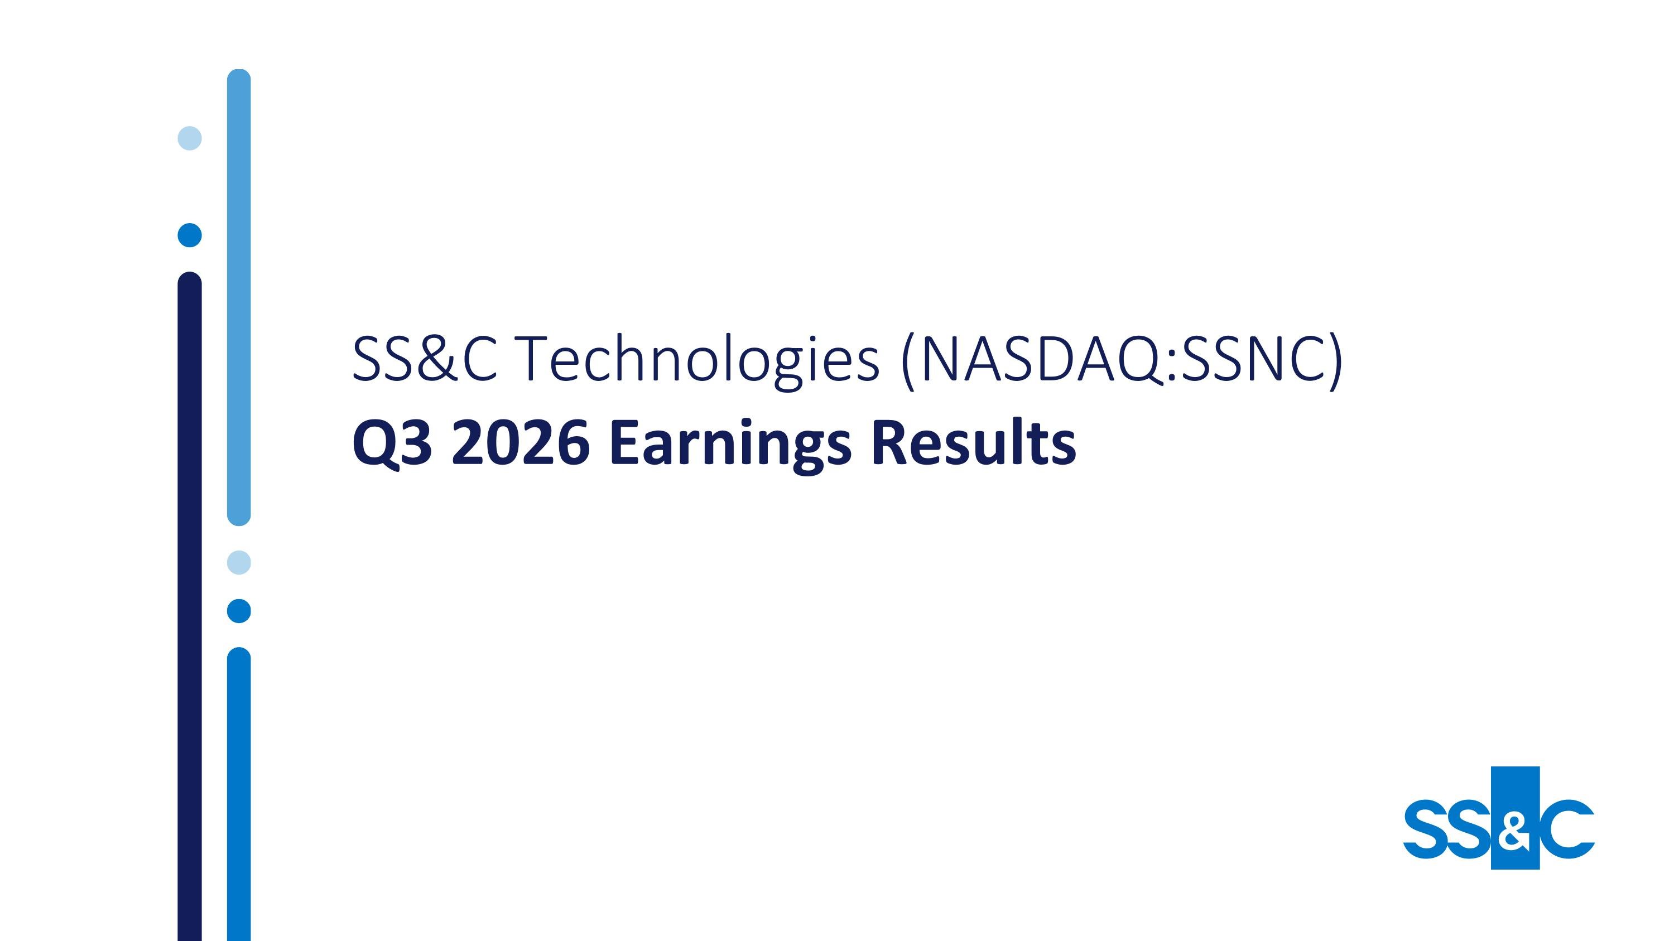
SS&C Technologies (NASDAQ:SSNC)?Q3 2026 Earnings Results

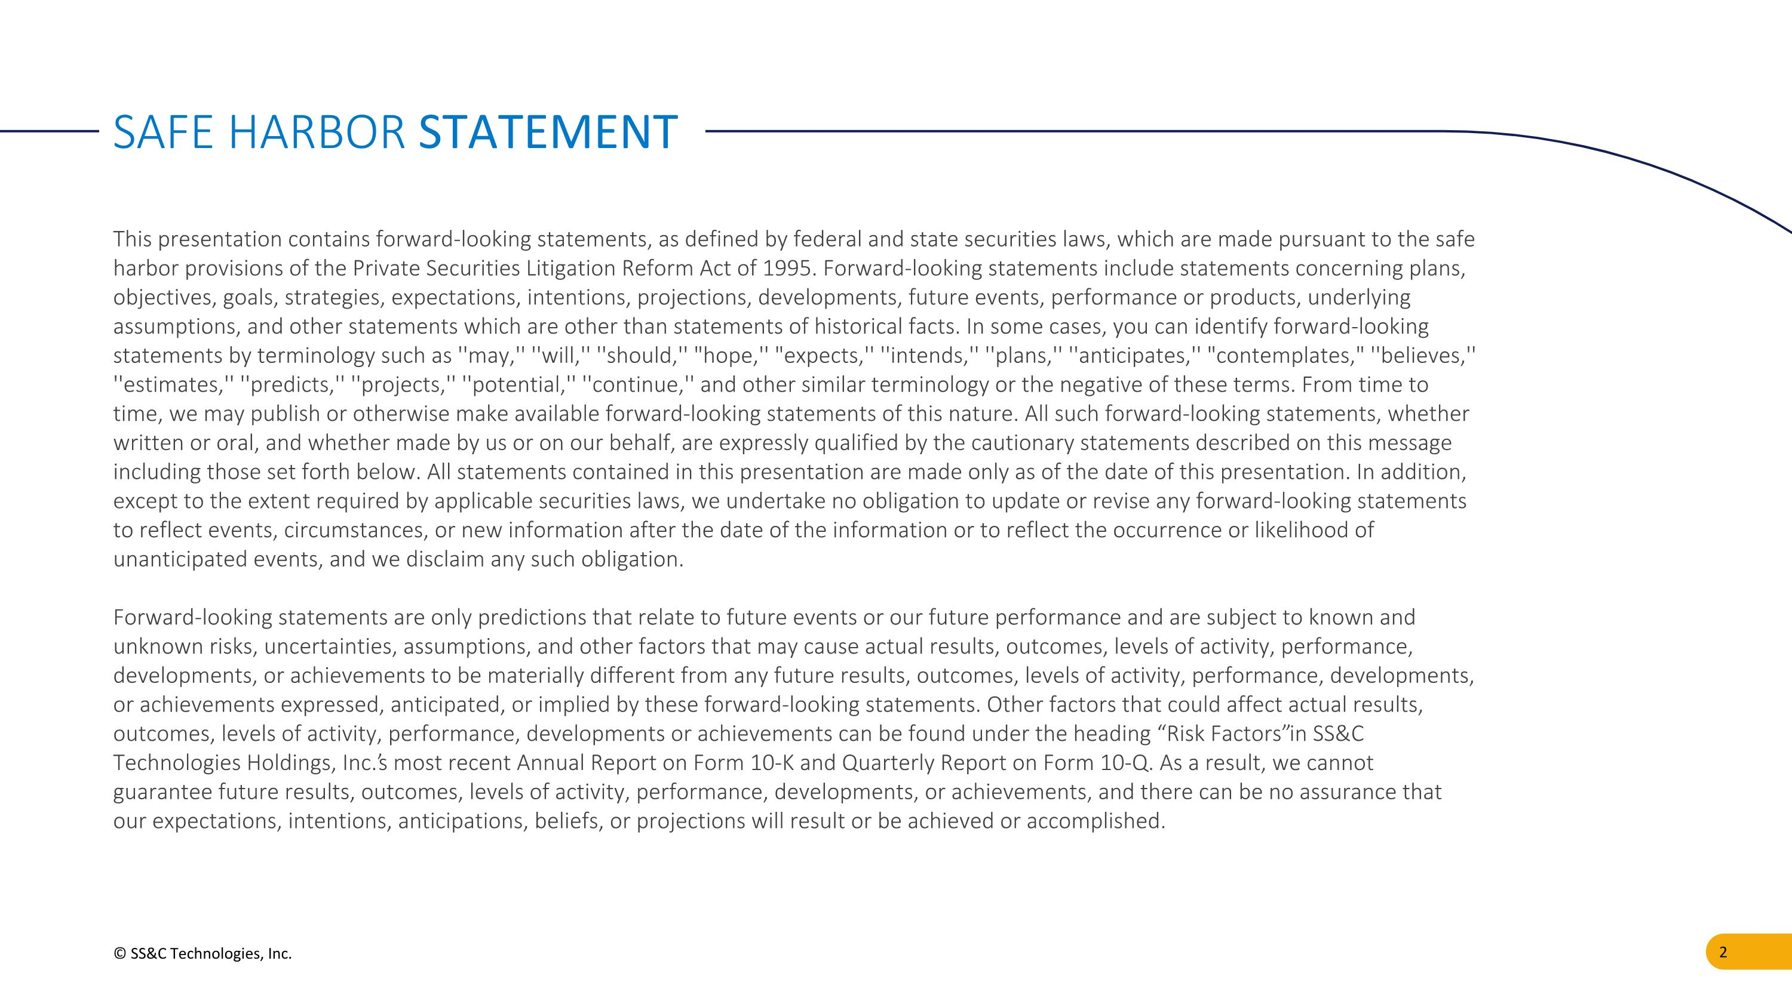
© SS&C Technologies, Inc. This presentation contains forward-looking statements, as defined by federal and state securities laws, which are made pursuant to the safe harbor provisions of the Private Securities Litigation Reform Act of 1995. Forward-looking statements include statements concerning plans, objectives, goals, strategies, expectations, intentions, projections, developments, future events, performance or products, underlying assumptions, and other statements which are other than statements of historical facts. In some cases, you can identify forward-looking statements by terminology such as ''may,'' ''will,'' ''should,'' "hope,'' "expects,'' ''intends,'' ''plans,'' ''anticipates,'' "contemplates," ''believes,'' ''estimates,'' ''predicts,'' ''projects,'' ''potential,'' ''continue,'' and other similar terminology or the negative of these terms. From time to time, we may publish or otherwise make available forward-looking statements of this nature. All such forward-looking statements, whether written or oral, and whether made by us or on our behalf, are expressly qualified by the cautionary statements described on this message including those set forth below. All statements contained in this presentation are made only as of the date of this presentation. In addition, except to the extent required by applicable securities laws, we undertake no obligation to update or revise any forward-looking statements to reflect events, circumstances, or new information after the date of the information or to reflect the occurrence or likelihood of unanticipated events, and we disclaim any such obligation.? ?Forward-looking statements are only predictions that relate to future events or our future performance and are subject to known and unknown risks, uncertainties, assumptions, and other factors that may cause actual results, outcomes, levels of activity, performance, developments, or achievements to be materially different from any future results, outcomes, levels of activity, performance, developments, or achievements expressed, anticipated, or implied by these forward-looking statements. Other factors that could affect actual results, outcomes, levels of activity, performance, developments or achievements can be found under the heading “Risk Factors” in SS&C Technologies Holdings, Inc.’s most recent Annual Report on Form 10-K and Quarterly Report on Form 10-Q. As a result, we cannot guarantee future results, outcomes, levels of activity, performance, developments, or achievements, and there can be no assurance that our expectations, intentions, anticipations, beliefs, or projections will result or be achieved or accomplished. SAFE HARBOR STATEMENT

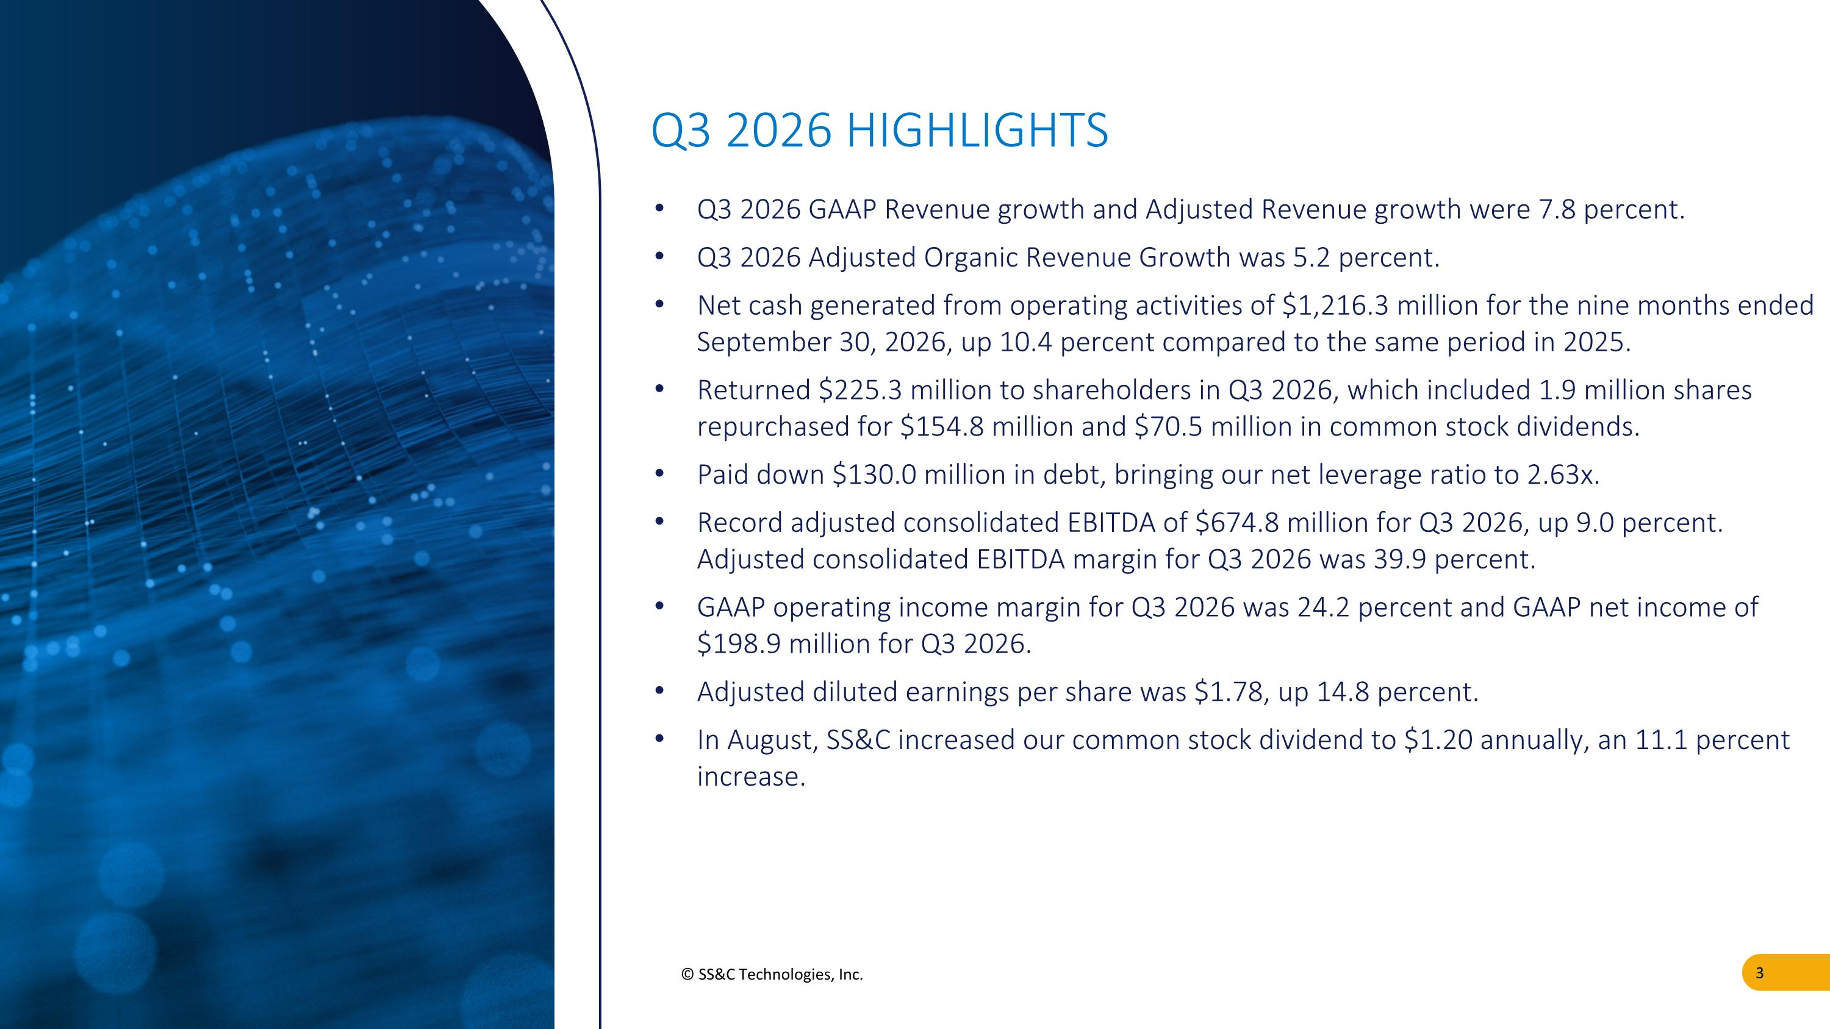
© SS&C Technologies, Inc. Q3 2026 GAAP Revenue growth and Adjusted Revenue growth were 7.8 percent. Q3 2026 Adjusted Organic Revenue Growth was 5.2 percent. Net cash generated from operating activities of $1,216.3 million for the nine months ended September 30, 2026, up 10.4 percent compared to the same period in 2025. Returned $225.3 million to shareholders in Q3 2026, which included 1.9 million shares repurchased for $154.8 million and $70.5 million in common stock dividends. Paid down $130.0 million in debt, bringing our net leverage ratio to 2.63x. Record adjusted consolidated EBITDA of $674.8 million for Q3 2026, up 9.0 percent. Adjusted consolidated EBITDA margin for Q3 2026 was 39.9 percent. GAAP operating income margin for Q3 2026 was 24.2 percent and GAAP net income of $198.9 million for Q3 2026. Adjusted diluted earnings per share was $1.78, up 14.8 percent. In August, SS&C increased our common stock dividend to $1.20 annually, an 11.1 percent increase. Q3 2026 HIGHLIGHTS

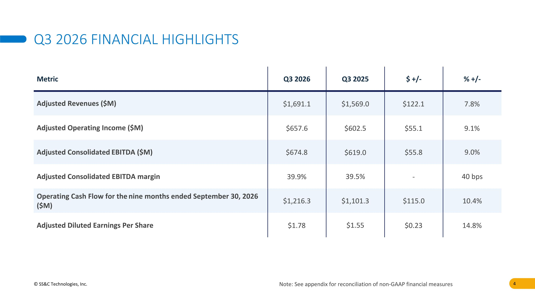
© SS&C Technologies, Inc. Q3 2026 FINANCIAL HIGHLIGHTS Note: See appendix for reconciliation of non-GAAP financial measures Metric Q3 2026 Q3 2025 $ +/- % +/- Adjusted Revenues ($M) $1,691.1 $1,569.0 $122.1 7.8% Adjusted Operating Income ($M) $657.6 $602.5 $55.1 9.1% Adjusted Consolidated EBITDA ($M) $674.8 $619.0 $55.8 9.0% Adjusted Consolidated EBITDA margin 39.9% 39.5% - 40 bps Operating Cash Flow for the nine months ended September 30, 2026 ($M) $1,216.3 $1,101.3 $115.0 10.4% Adjusted Diluted Earnings Per Share $1.78 $1.55 $0.23 14.8%

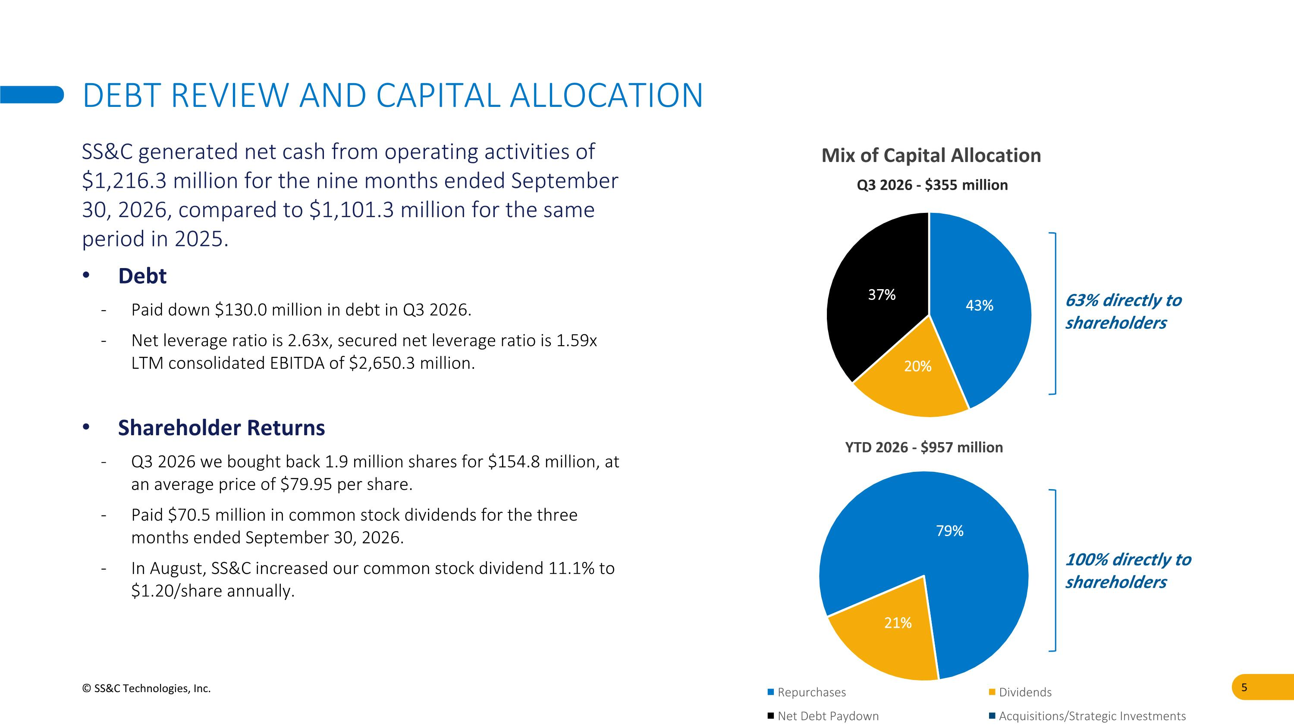
DEBT REVIEW AND CAPITAL ALLOCATION © SS&C Technologies, Inc. SS&C generated net cash from operating activities of $1,216.3 million for the nine months ended September 30, 2026, compared to $1,101.3 million for the same period in 2025. Debt Paid down $130.0 million in debt in Q3 2026. Net leverage ratio is 2.63x, secured net leverage ratio is 1.59x LTM consolidated EBITDA of $2,650.3 million. Shareholder Returns Q3 2026 we bought back 1.9 million shares for $154.8 million, at an average price of $79.95 per share. Paid $70.5 million in common stock dividends for the three months ended September 30, 2026. In August, SS&C increased our common stock dividend 11.1% to $1.20/share annually. 100% directly to shareholders 63% directly to shareholders Mix of Capital Allocation

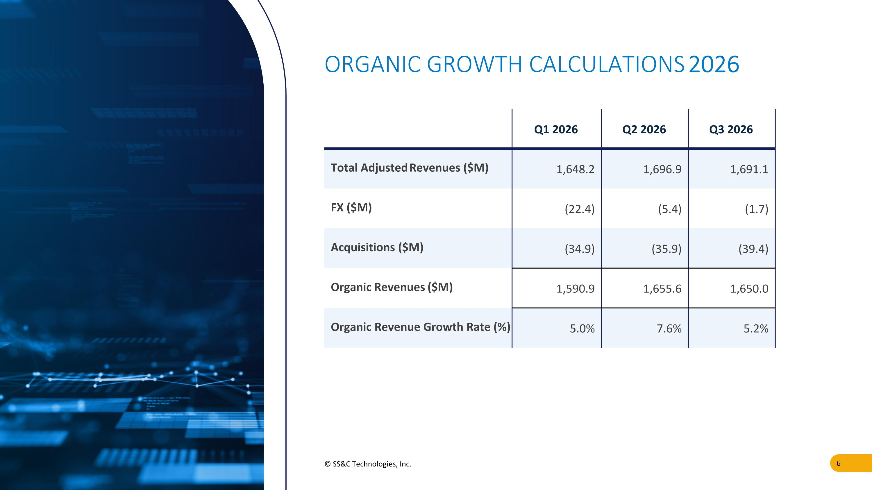
© SS&C Technologies, Inc. ORGANIC GROWTH CALCULATIONS 2026 Q1 2026 Q2 2026 Q3 2026 Total Adjusted Revenues ($M) 1,648.2 1,696.9 1,691.1 FX ($M) (22.4) (5.4) (1.7) Acquisitions ($M) (34.9) (35.9) (39.4) Organic Revenues ($M) 1,590.9 1,655.6 1,650.0 Organic Revenue Growth Rate (%) 5.0% 7.6% 5.2%

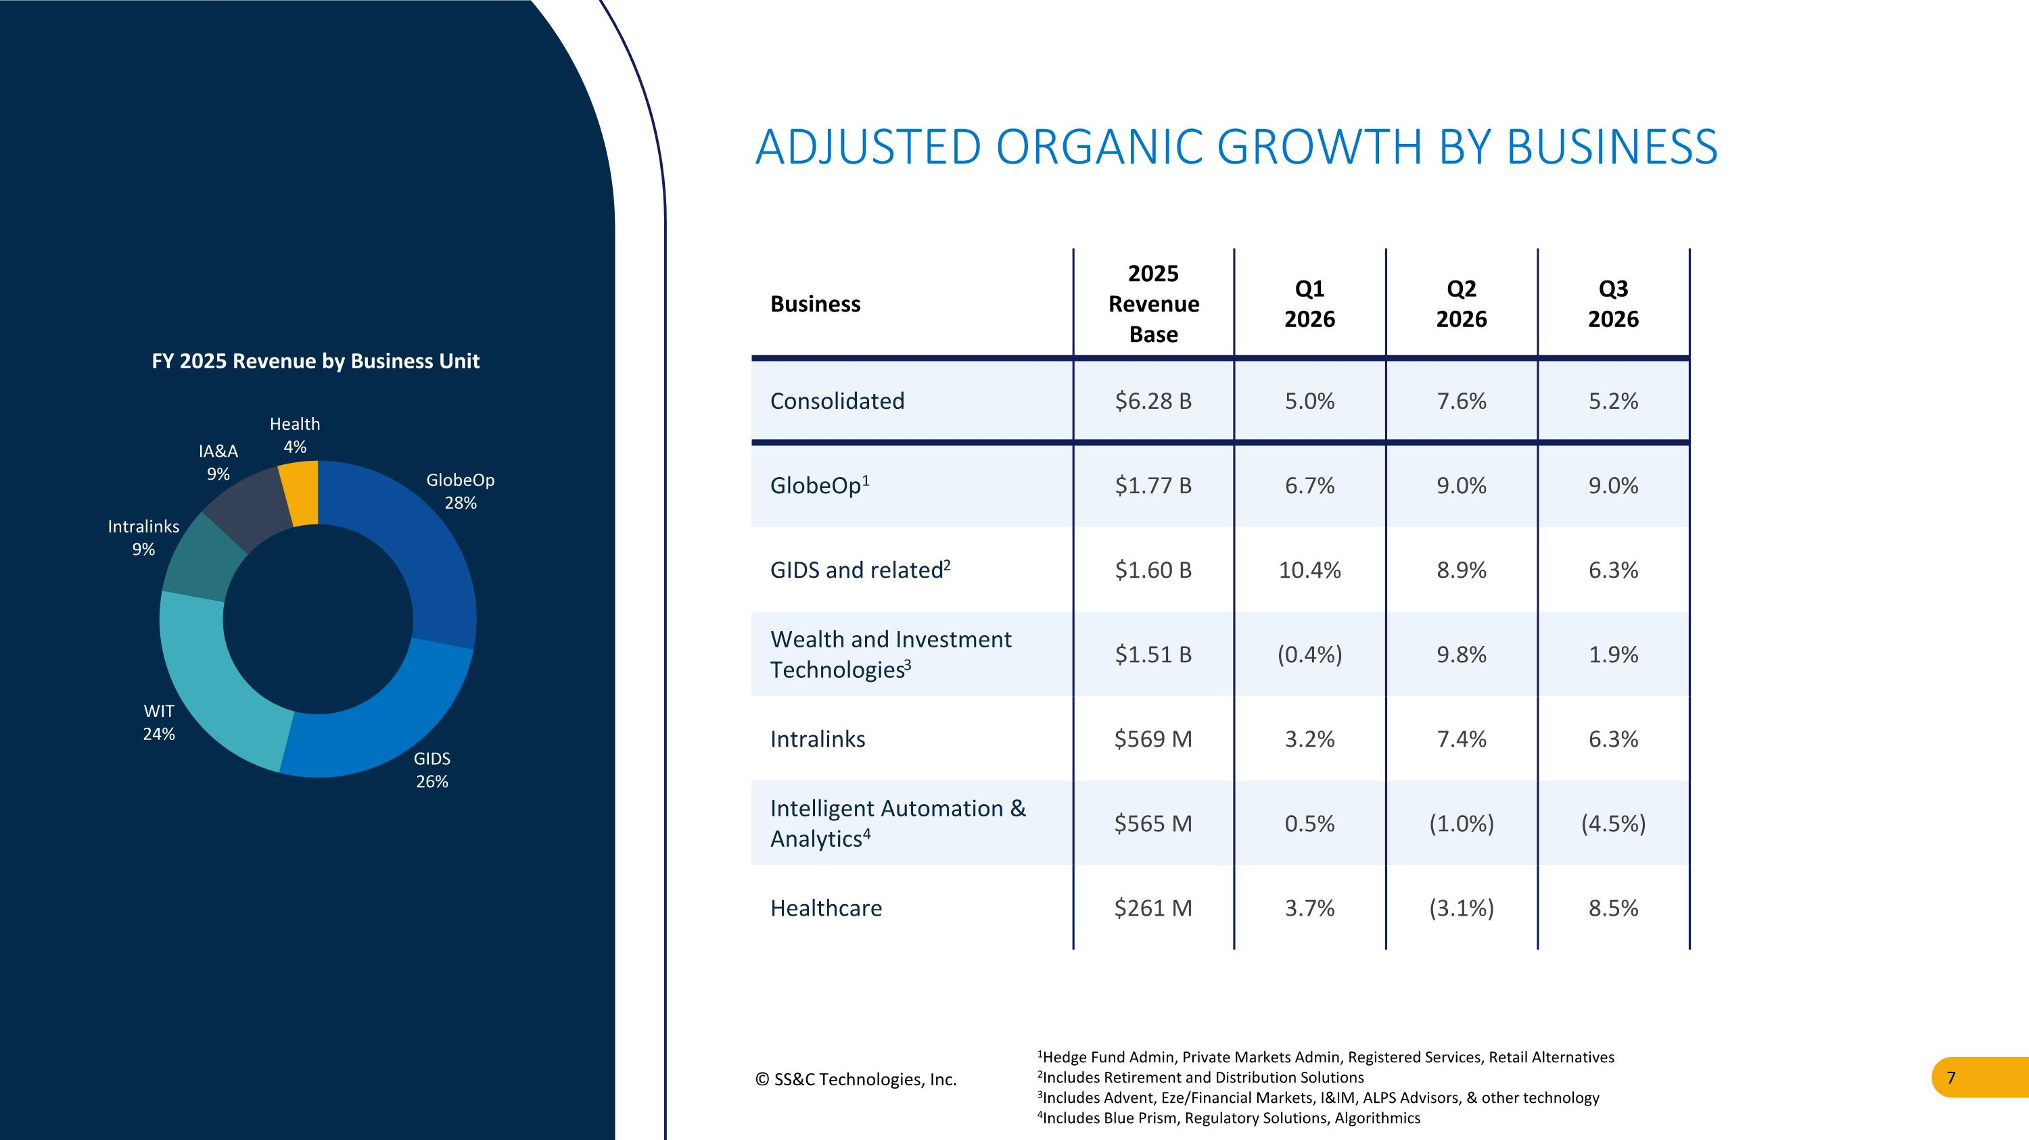
© SS&C Technologies, Inc. ADJUSTED ORGANIC GROWTH BY BUSINESS 1Hedge Fund Admin, Private Markets Admin, Registered Services, Retail Alternatives 2Includes Retirement and Distribution Solutions 3Includes Advent, Eze/Financial Markets, I&IM, ALPS Advisors, & other technology 4Includes Blue Prism, Regulatory Solutions, Algorithmics Business 2025 Revenue Base Q1 2026 Q2 2026 Q3 2026 Consolidated $6.28 B 5.0% 7.6% 5.2% GlobeOp1 $1.77 B 6.7% 9.0% 9.0% GIDS and related2 $1.60 B 10.4% 8.9% 6.3% Wealth and Investment Technologies3 $1.51 B (0.4%) 9.8% 1.9% Intralinks $569 M 3.2% 7.4% 6.3% Intelligent Automation & Analytics4 $565 M 0.5% (1.0%) (4.5%) Healthcare $261 M 3.7% (3.1%) 8.5%

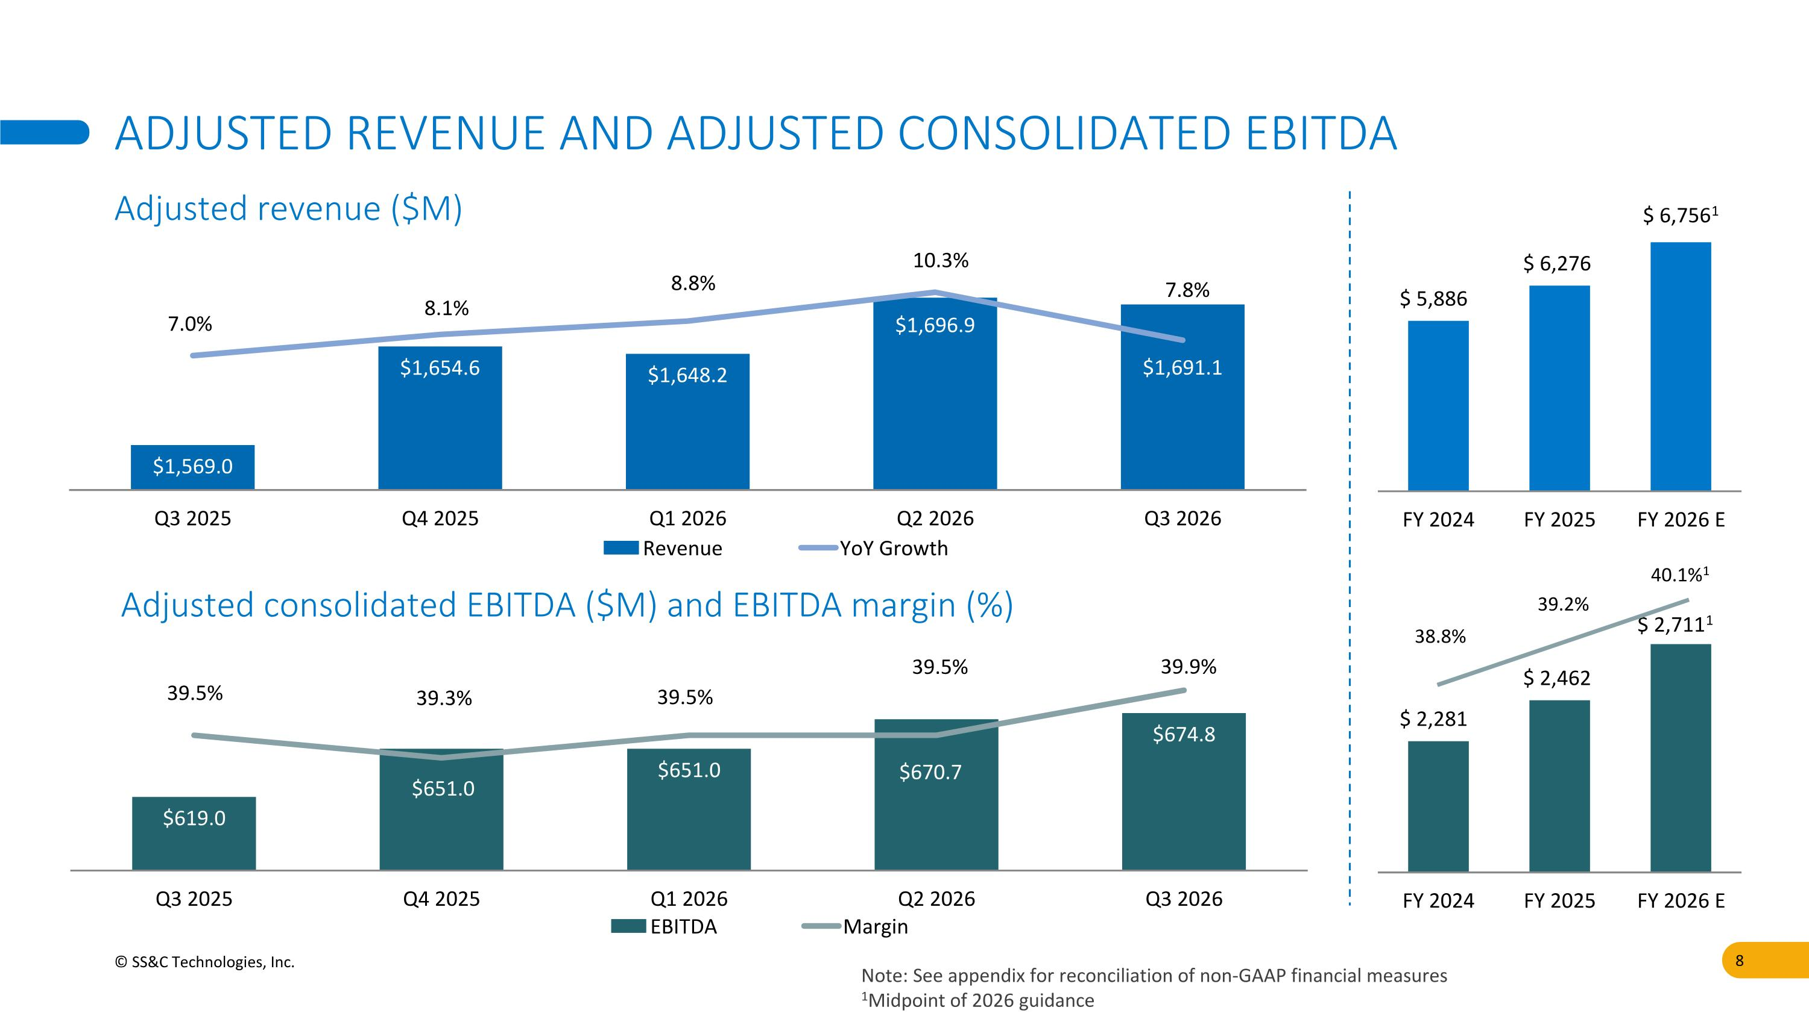
Adjusted consolidated EBITDA ($M) and EBITDA margin (%) 38.8% 39.2% 40.1%1 © SS&C Technologies, Inc. ADJUSTED REVENUE AND ADJUSTED CONSOLIDATED EBITDA Adjusted revenue ($M) Note: See appendix for reconciliation of non-GAAP financial measures 1Midpoint of 2026 guidance

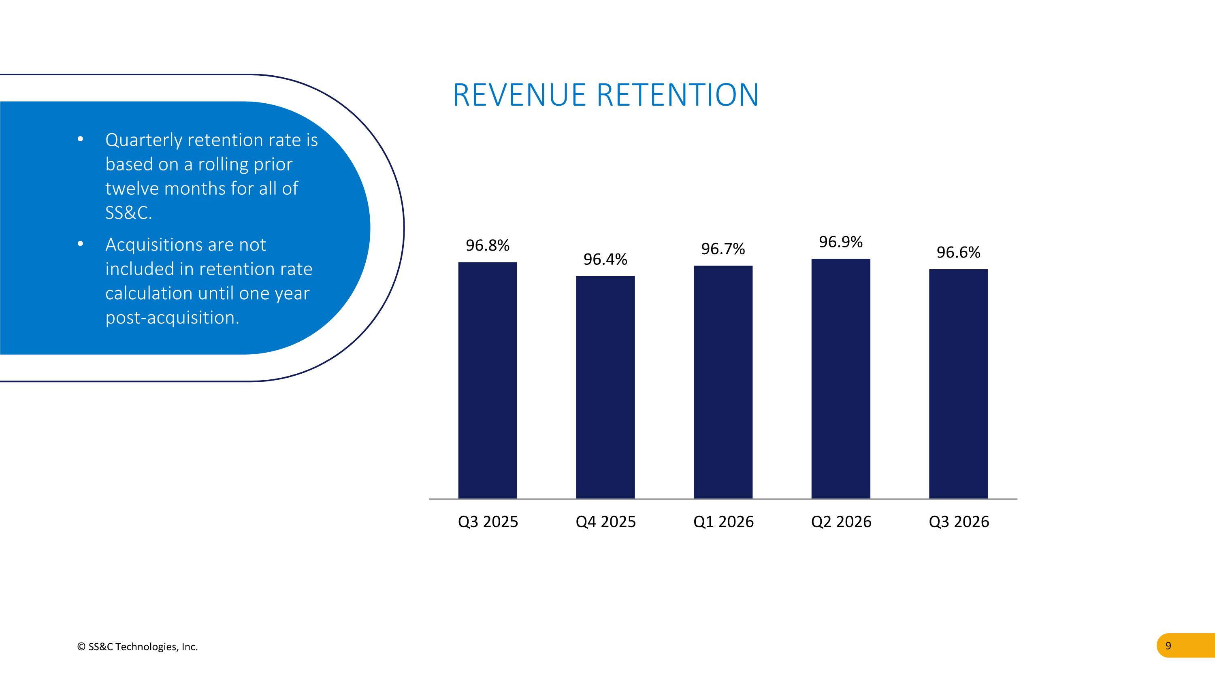
© SS&C Technologies, Inc. Quarterly retention rate is based on a rolling prior twelve months for all of SS&C. Acquisitions are not included in retention rate calculation until one year post-acquisition. REVENUE RETENTION

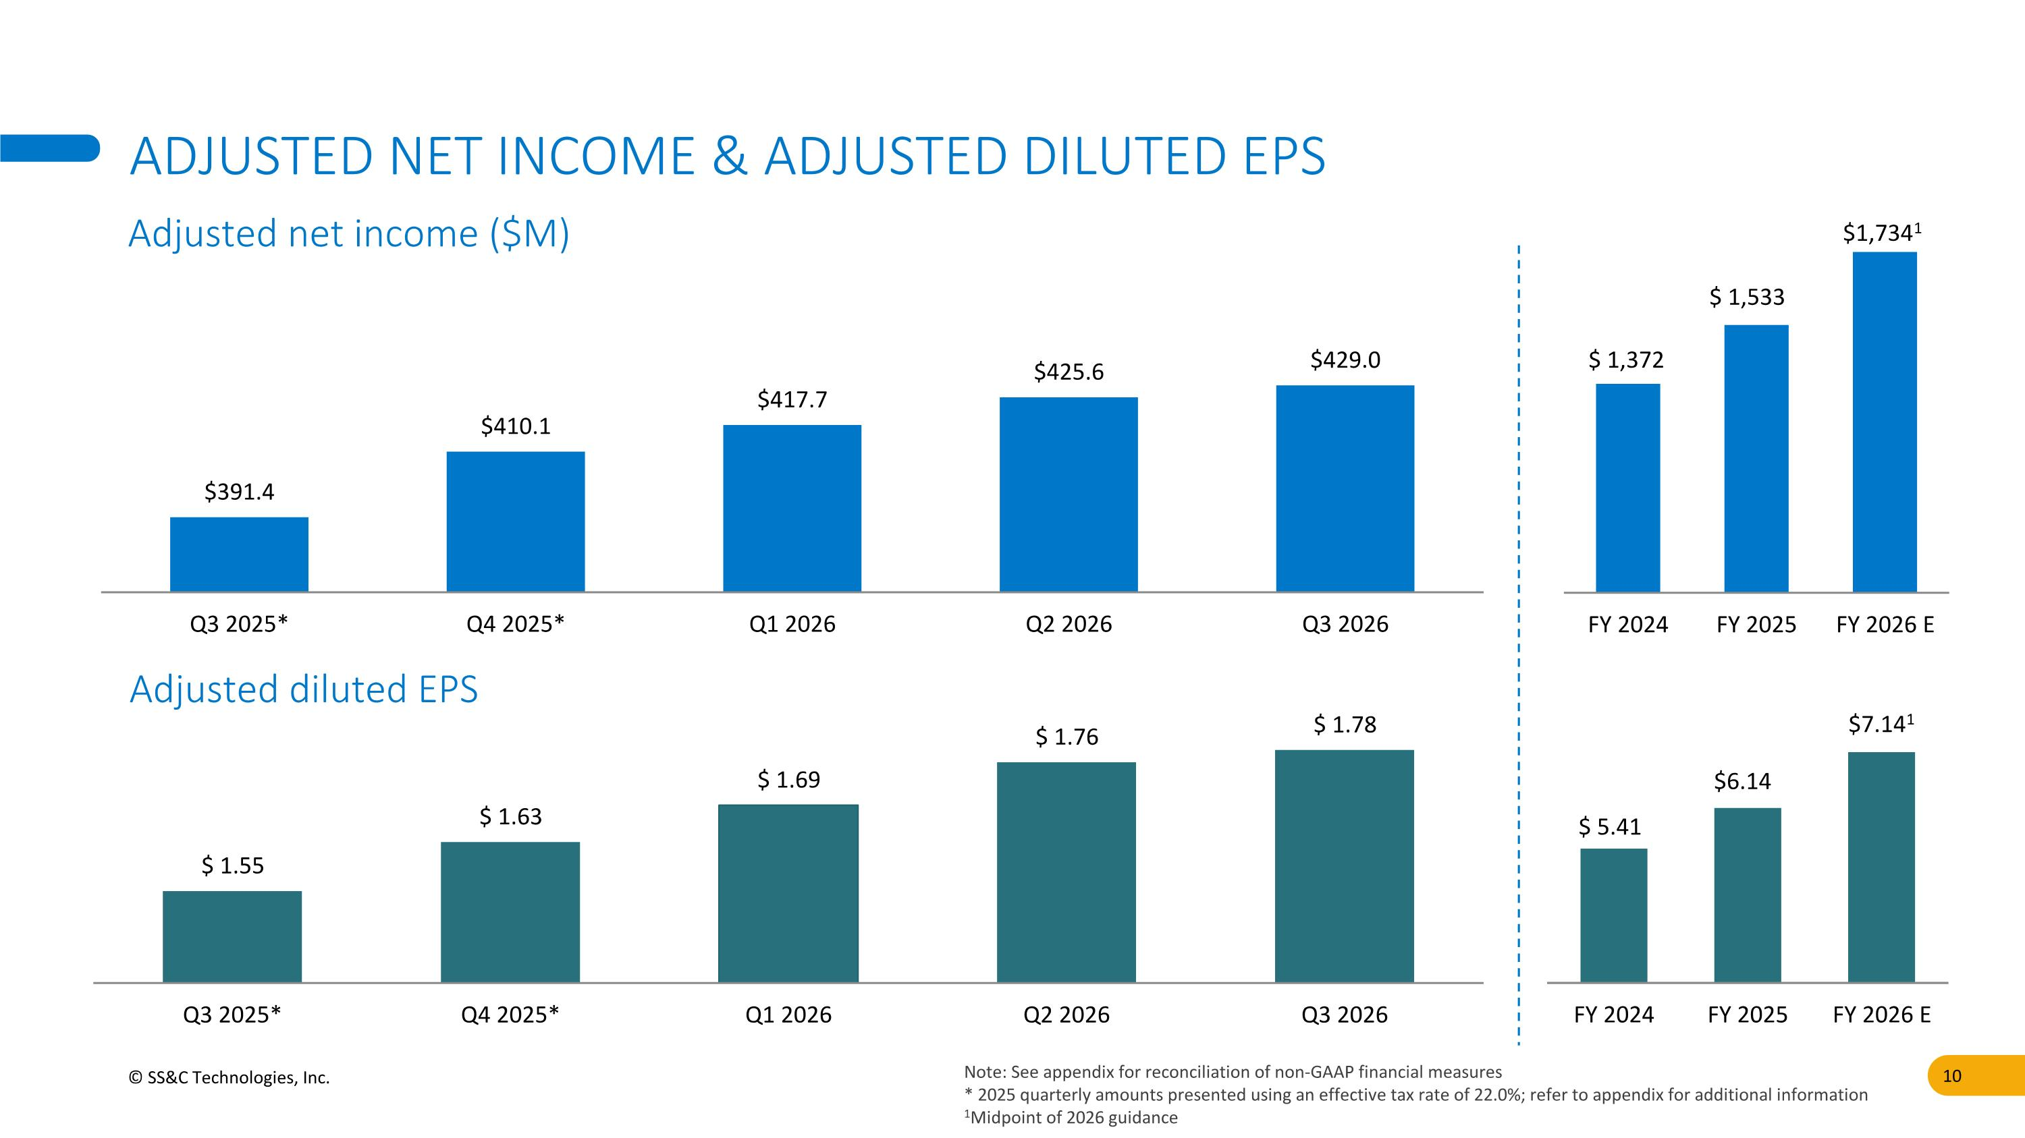
© SS&C Technologies, Inc. ADJUSTED NET INCOME & ADJUSTED DILUTED EPS Adjusted net income ($M) Adjusted diluted EPS Note: See appendix for reconciliation of non-GAAP financial measures * 2025 quarterly amounts presented using an effective tax rate of 22.0%; refer to appendix for additional information 1Midpoint of 2026 guidance

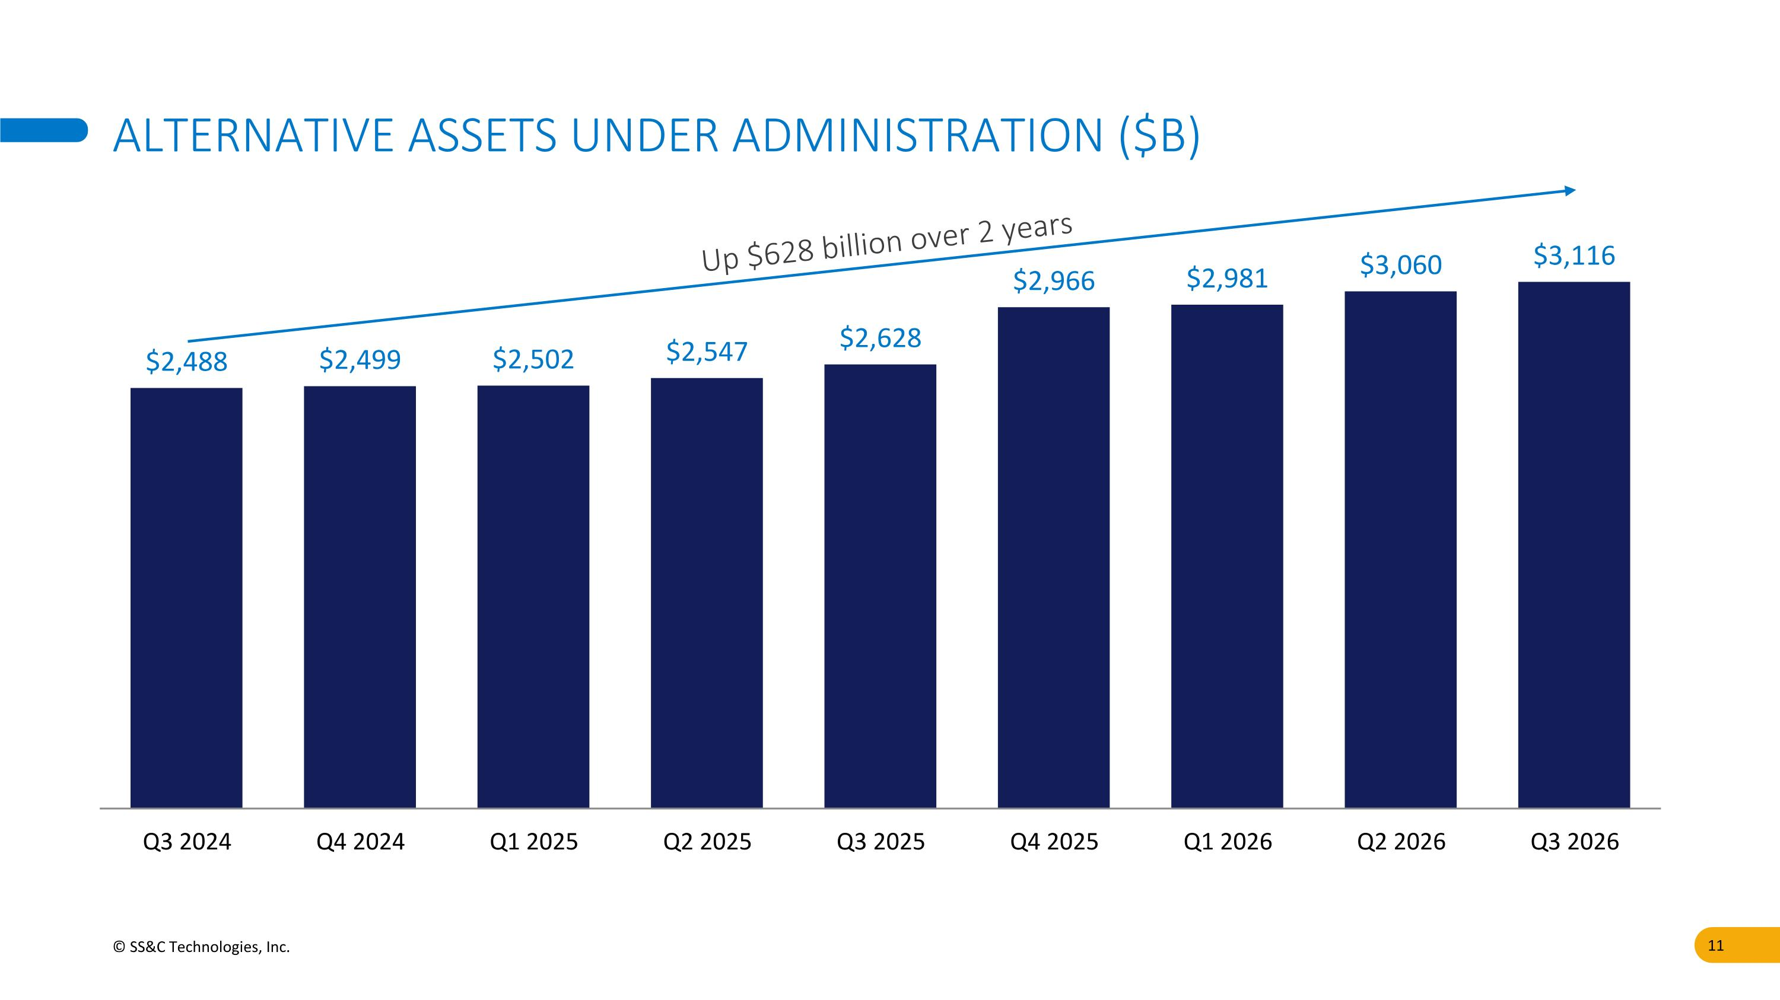
© SS&C Technologies, Inc. ALTERNATIVE ASSETS UNDER ADMINISTRATION ($B) Up $628 billion over 2 years

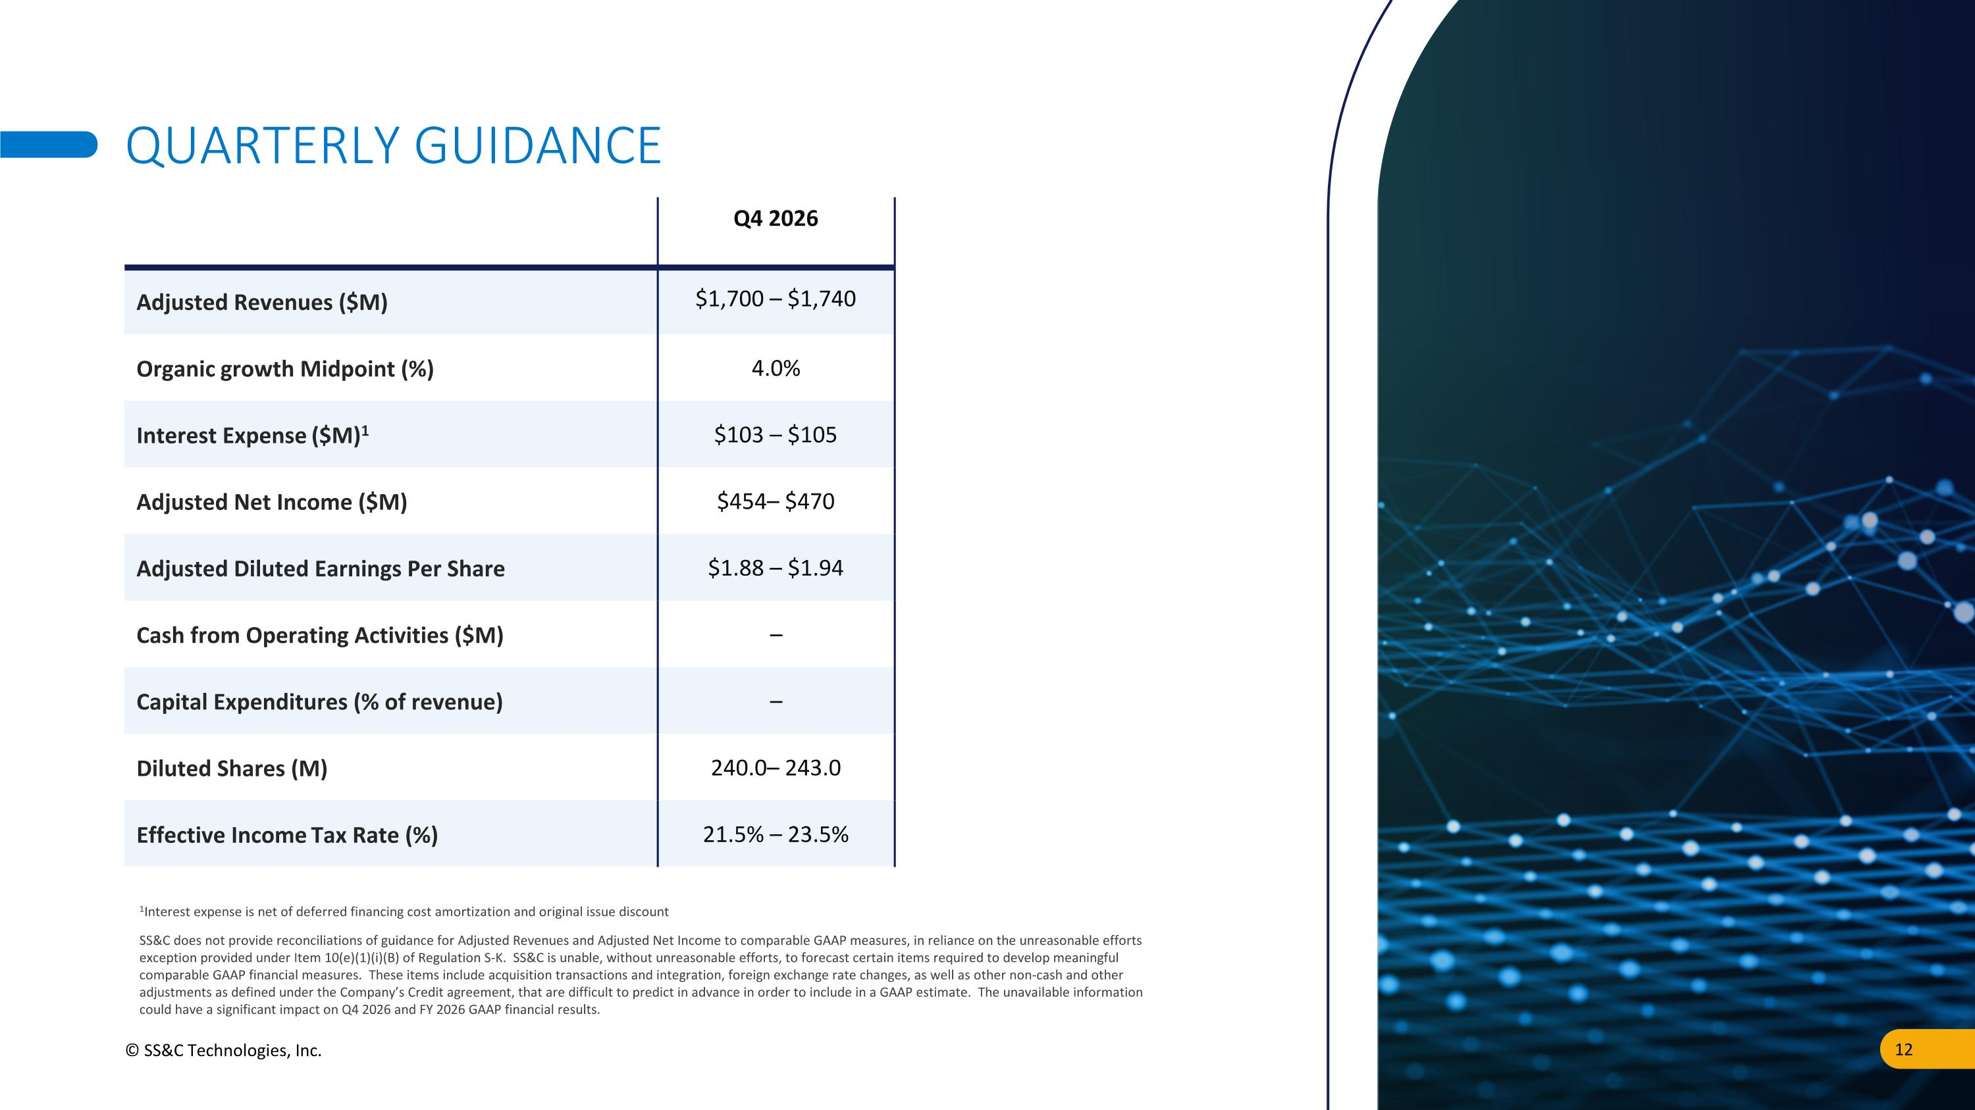
QUARTERLY GUIDANCE Q4 2026 Adjusted Revenues ($M) $1,700 – $1,740 Organic growth Midpoint (%) 4.0% Interest Expense ($M)1 $103 – $105 Adjusted Net Income ($M) $454– $470 Adjusted Diluted Earnings Per Share $1.88 – $1.94 Cash from Operating Activities ($M) – Capital Expenditures (% of revenue) – Diluted Shares (M) 240.0– 243.0 Effective Income Tax Rate (%) 21.5% – 23.5% SS&C does not provide reconciliations of guidance for Adjusted Revenues and Adjusted Net Income to comparable GAAP measures, in reliance on the unreasonable efforts exception provided under Item 10(e)(1)(i)(B) of Regulation S-K. SS&C is unable, without unreasonable efforts, to forecast certain items required to develop meaningful comparable GAAP financial measures. These items include acquisition transactions and integration, foreign exchange rate changes, as well as other non-cash and other adjustments as defined under the Company’s Credit agreement, that are difficult to predict in advance in order to include in a GAAP estimate. The unavailable information could have a significant impact on Q4 2026 and FY 2026 GAAP financial results. 1Interest expense is net of deferred financing cost amortization and original issue discount © SS&C Technologies, Inc.

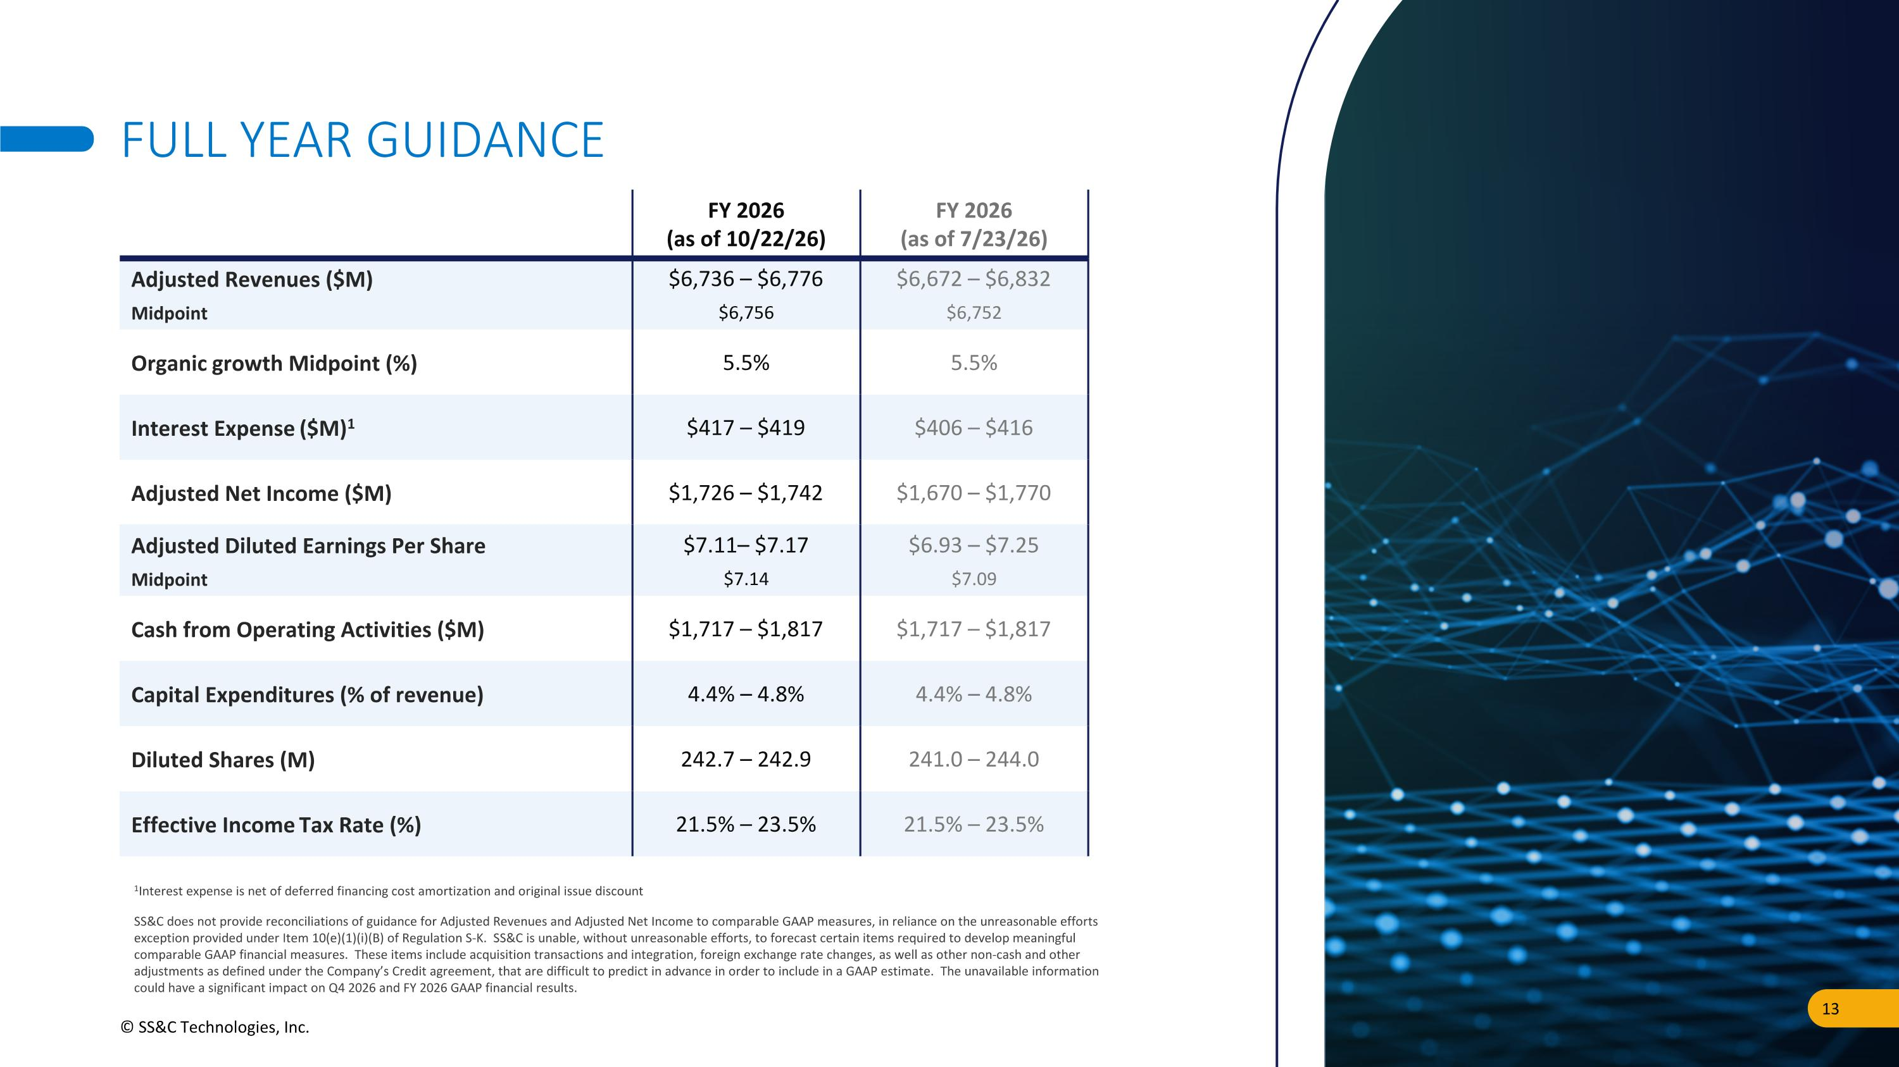
FULL YEAR GUIDANCE FY 2026 (as of 10/22/26) FY 2026 (as of 7/23/26) Adjusted Revenues ($M) Midpoint $6,736 – $6,776 $6,756 $6,672 – $6,832 $6,752 Organic growth Midpoint (%) 5.5% 5.5% Interest Expense ($M)1 $417 – $419 $406 – $416 Adjusted Net Income ($M) $1,726 – $1,742 $1,670 – $1,770 Adjusted Diluted Earnings Per Share Midpoint $7.11– $7.17 $7.14 $6.93 – $7.25 $7.09 Cash from Operating Activities ($M) $1,717 – $1,817 $1,717 – $1,817 Capital Expenditures (% of revenue) 4.4% – 4.8% 4.4% – 4.8% Diluted Shares (M) 242.7 – 242.9 241.0 – 244.0 Effective Income Tax Rate (%) 21.5% – 23.5% 21.5% – 23.5% SS&C does not provide reconciliations of guidance for Adjusted Revenues and Adjusted Net Income to comparable GAAP measures, in reliance on the unreasonable efforts exception provided under Item 10(e)(1)(i)(B) of Regulation S-K. SS&C is unable, without unreasonable efforts, to forecast certain items required to develop meaningful comparable GAAP financial measures. These items include acquisition transactions and integration, foreign exchange rate changes, as well as other non-cash and other adjustments as defined under the Company’s Credit agreement, that are difficult to predict in advance in order to include in a GAAP estimate. The unavailable information could have a significant impact on Q4 2026 and FY 2026 GAAP financial results. 1Interest expense is net of deferred financing cost amortization and original issue discount © SS&C Technologies, Inc.


APPENDIX

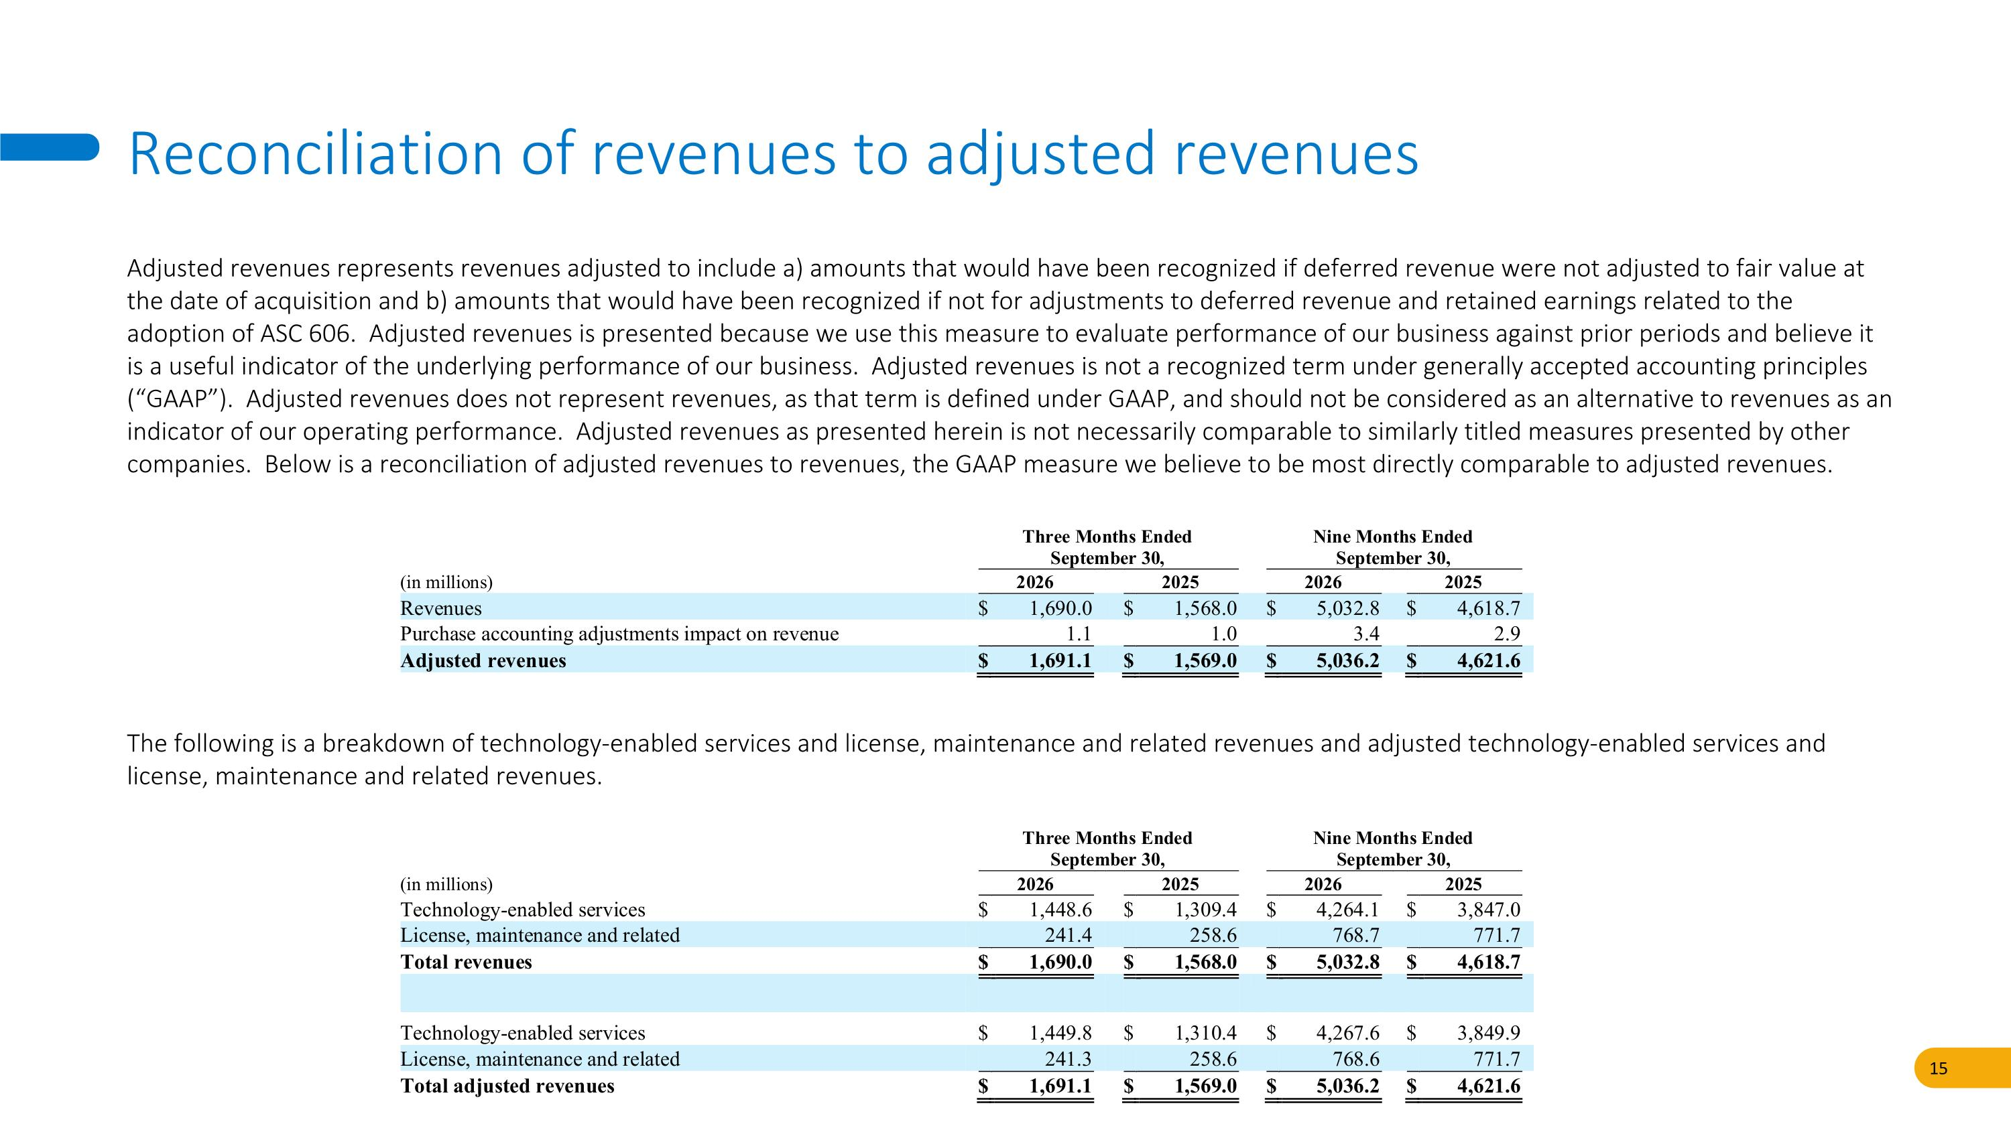
Adjusted revenues represents revenues adjusted to include a) amounts that would have been recognized if deferred revenue were not adjusted to fair value at the date of acquisition and b) amounts that would have been recognized if not for adjustments to deferred revenue and retained earnings related to the adoption of ASC 606. Adjusted revenues is presented because we use this measure to evaluate performance of our business against prior periods and believe it is a useful indicator of the underlying performance of our business. Adjusted revenues is not a recognized term under generally accepted accounting principles (“GAAP”). Adjusted revenues does not represent revenues, as that term is defined under GAAP, and should not be considered as an alternative to revenues as an indicator of our operating performance. Adjusted revenues as presented herein is not necessarily comparable to similarly titled measures presented by other companies. Below is a reconciliation of adjusted revenues to revenues, the GAAP measure we believe to be most directly comparable to adjusted revenues. Reconciliation of revenues to adjusted revenues The following is a breakdown of technology-enabled services and license, maintenance and related revenues and adjusted technology-enabled services and license, maintenance and related revenues.

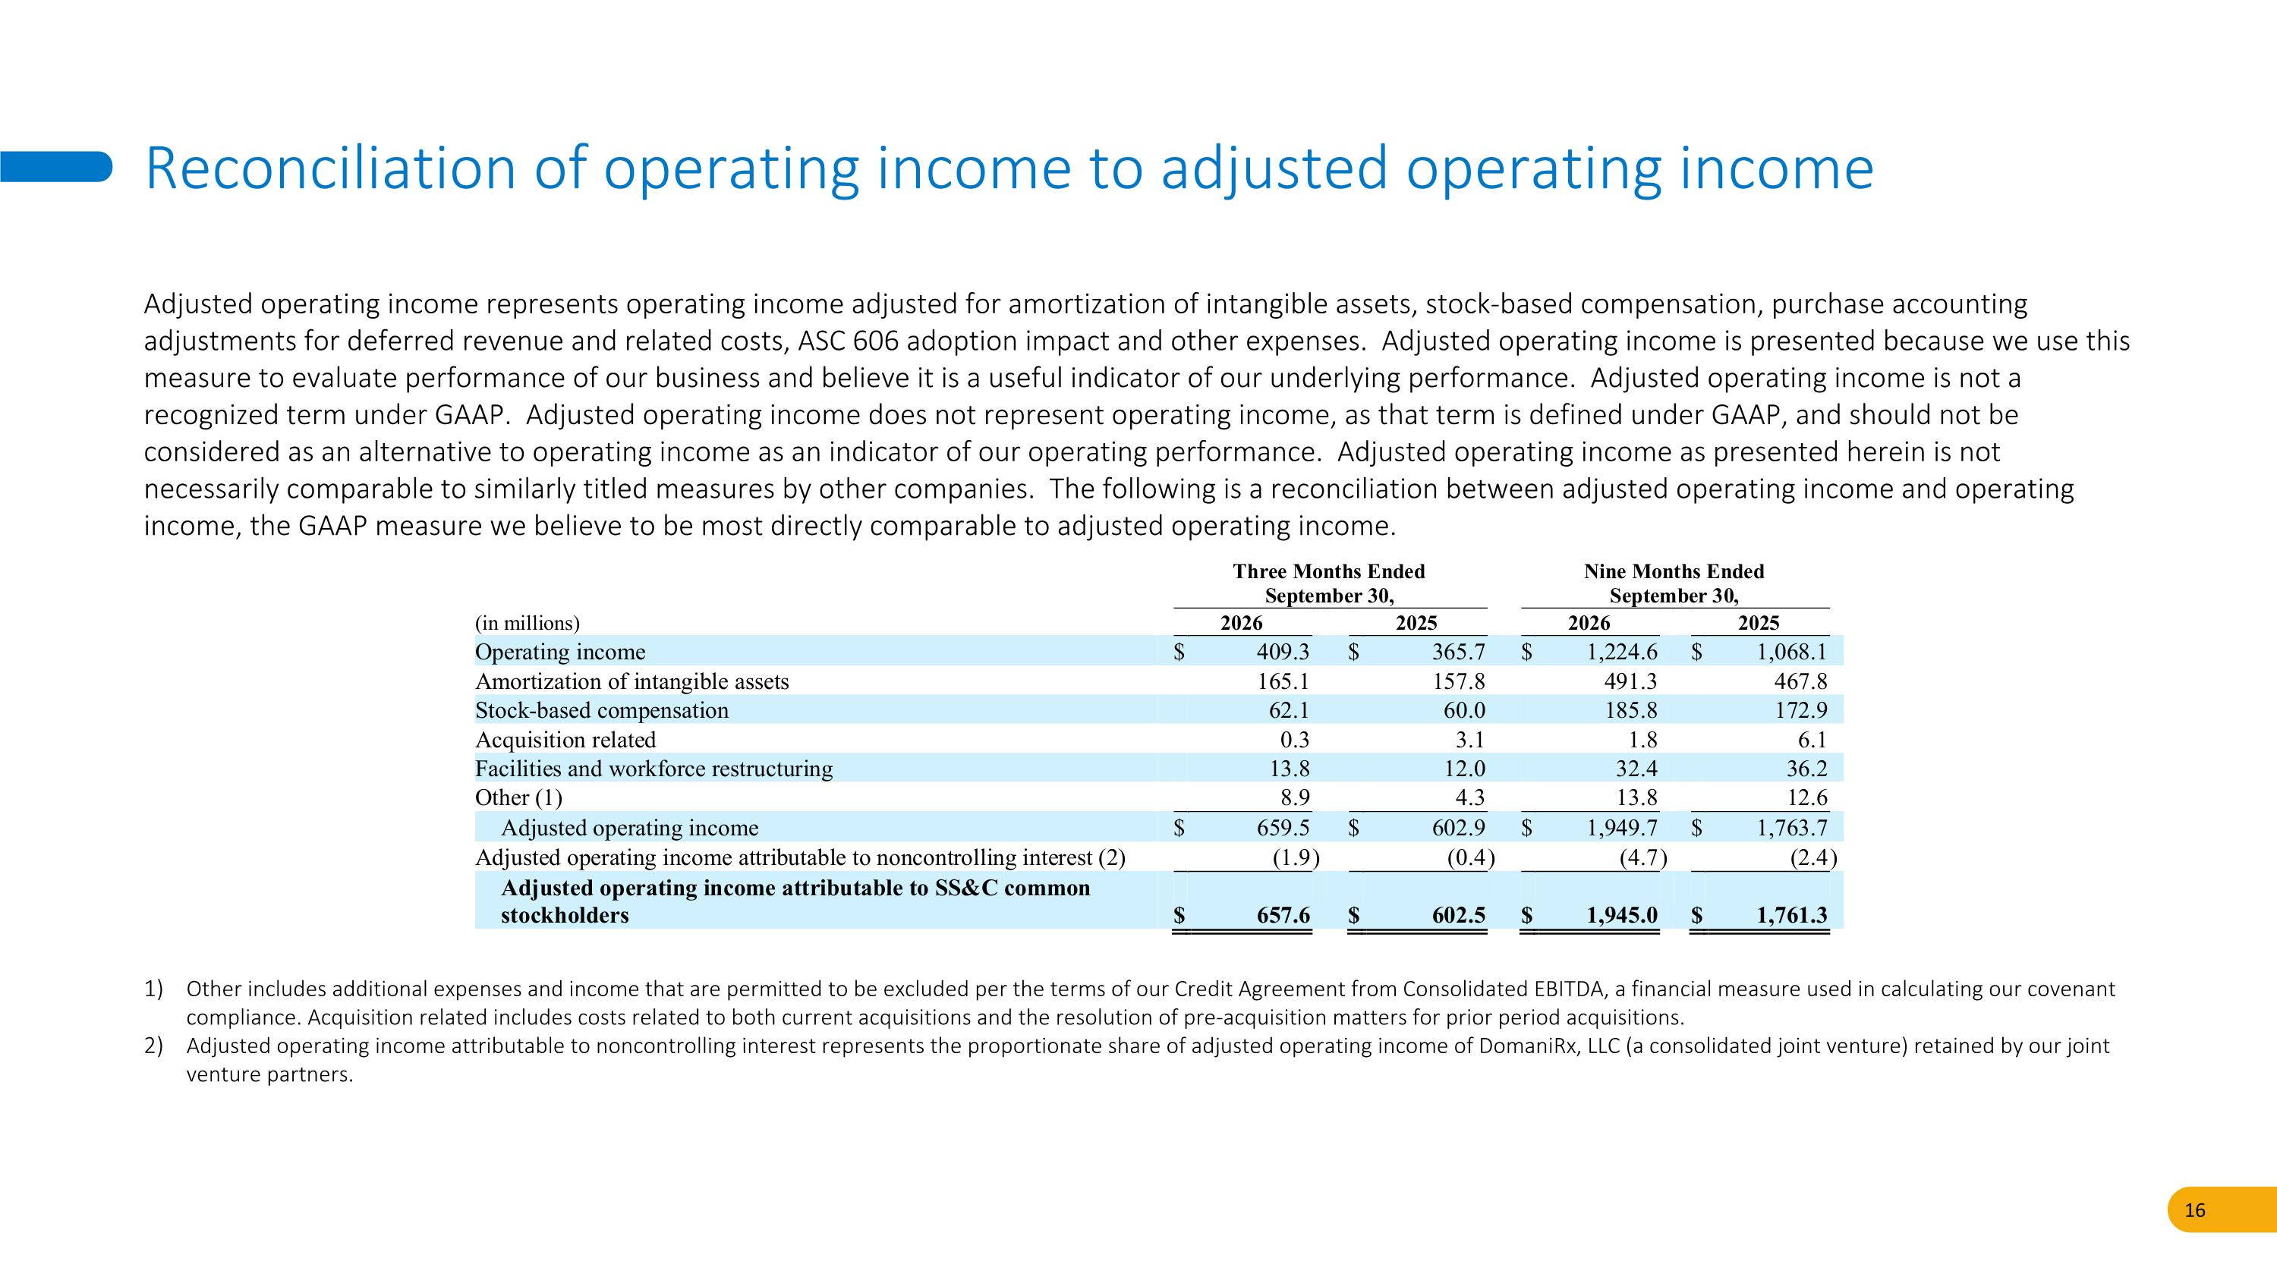
Adjusted operating income represents operating income adjusted for amortization of intangible assets, stock-based compensation, purchase accounting adjustments for deferred revenue and related costs, ASC 606 adoption impact and other expenses. Adjusted operating income is presented because we use this measure to evaluate performance of our business and believe it is a useful indicator of our underlying performance. Adjusted operating income is not a recognized term under GAAP. Adjusted operating income does not represent operating income, as that term is defined under GAAP, and should not be considered as an alternative to operating income as an indicator of our operating performance. Adjusted operating income as presented herein is not necessarily comparable to similarly titled measures by other companies. The following is a reconciliation between adjusted operating income and operating income, the GAAP measure we believe to be most directly comparable to adjusted operating income. Reconciliation of operating income to adjusted operating income Other includes additional expenses and income that are permitted to be excluded per the terms of our Credit Agreement from Consolidated EBITDA, a financial measure used in calculating our covenant compliance. Acquisition related includes costs related to both current acquisitions and the resolution of pre-acquisition matters for prior period acquisitions. Adjusted operating income attributable to noncontrolling interest represents the proportionate share of adjusted operating income of DomaniRx, LLC (a consolidated joint venture) retained by our joint venture partners.

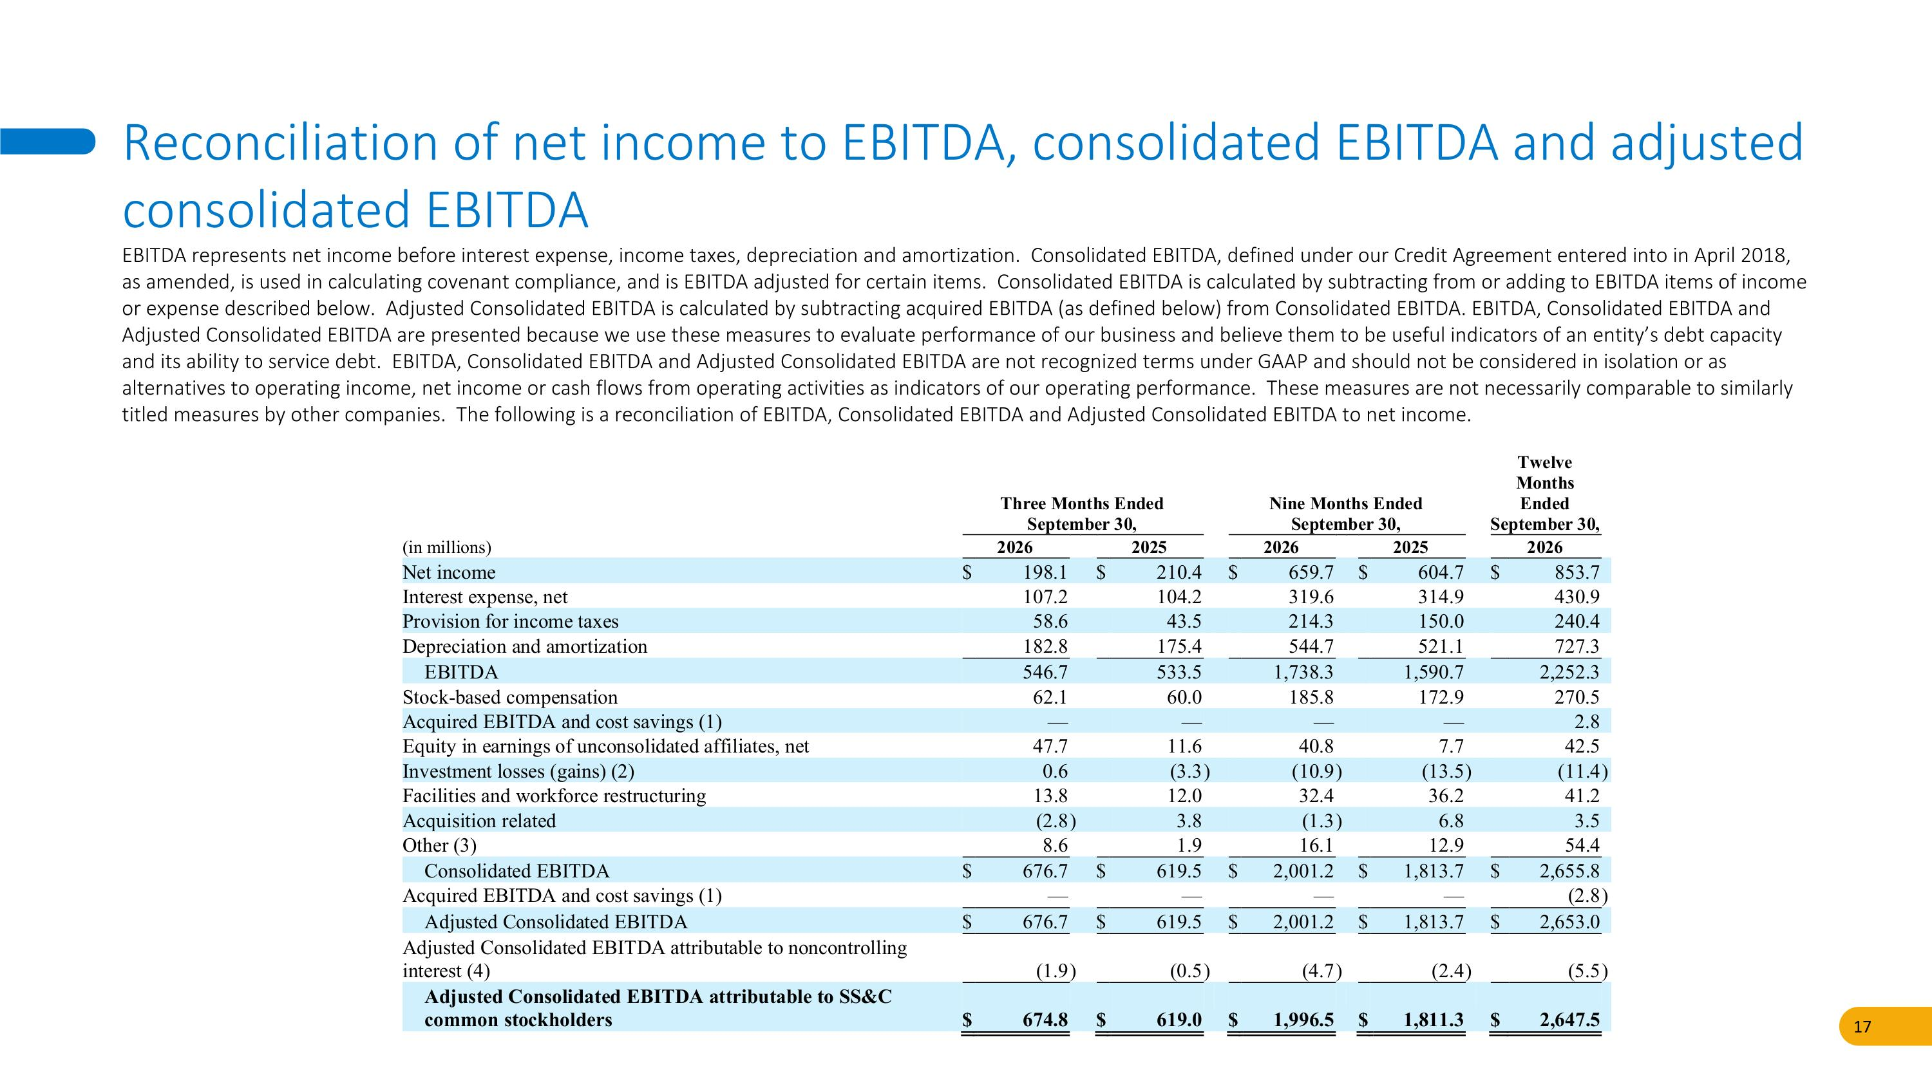
EBITDA represents net income before interest expense, income taxes, depreciation and amortization. Consolidated EBITDA, defined under our Credit Agreement entered into in April 2018, as amended, is used in calculating covenant compliance, and is EBITDA adjusted for certain items. Consolidated EBITDA is calculated by subtracting from or adding to EBITDA items of income or expense described below. Adjusted Consolidated EBITDA is calculated by subtracting acquired EBITDA (as defined below) from Consolidated EBITDA. EBITDA, Consolidated EBITDA and Adjusted Consolidated EBITDA are presented because we use these measures to evaluate performance of our business and believe them to be useful indicators of an entity’s debt capacity and its ability to service debt. EBITDA, Consolidated EBITDA and Adjusted Consolidated EBITDA are not recognized terms under GAAP and should not be considered in isolation or as alternatives to operating income, net income or cash flows from operating activities as indicators of our operating performance. These measures are not necessarily comparable to similarly titled measures by other companies. The following is a reconciliation of EBITDA, Consolidated EBITDA and Adjusted Consolidated EBITDA to net income. Reconciliation of net income to EBITDA, consolidated EBITDA and adjusted consolidated EBITDA

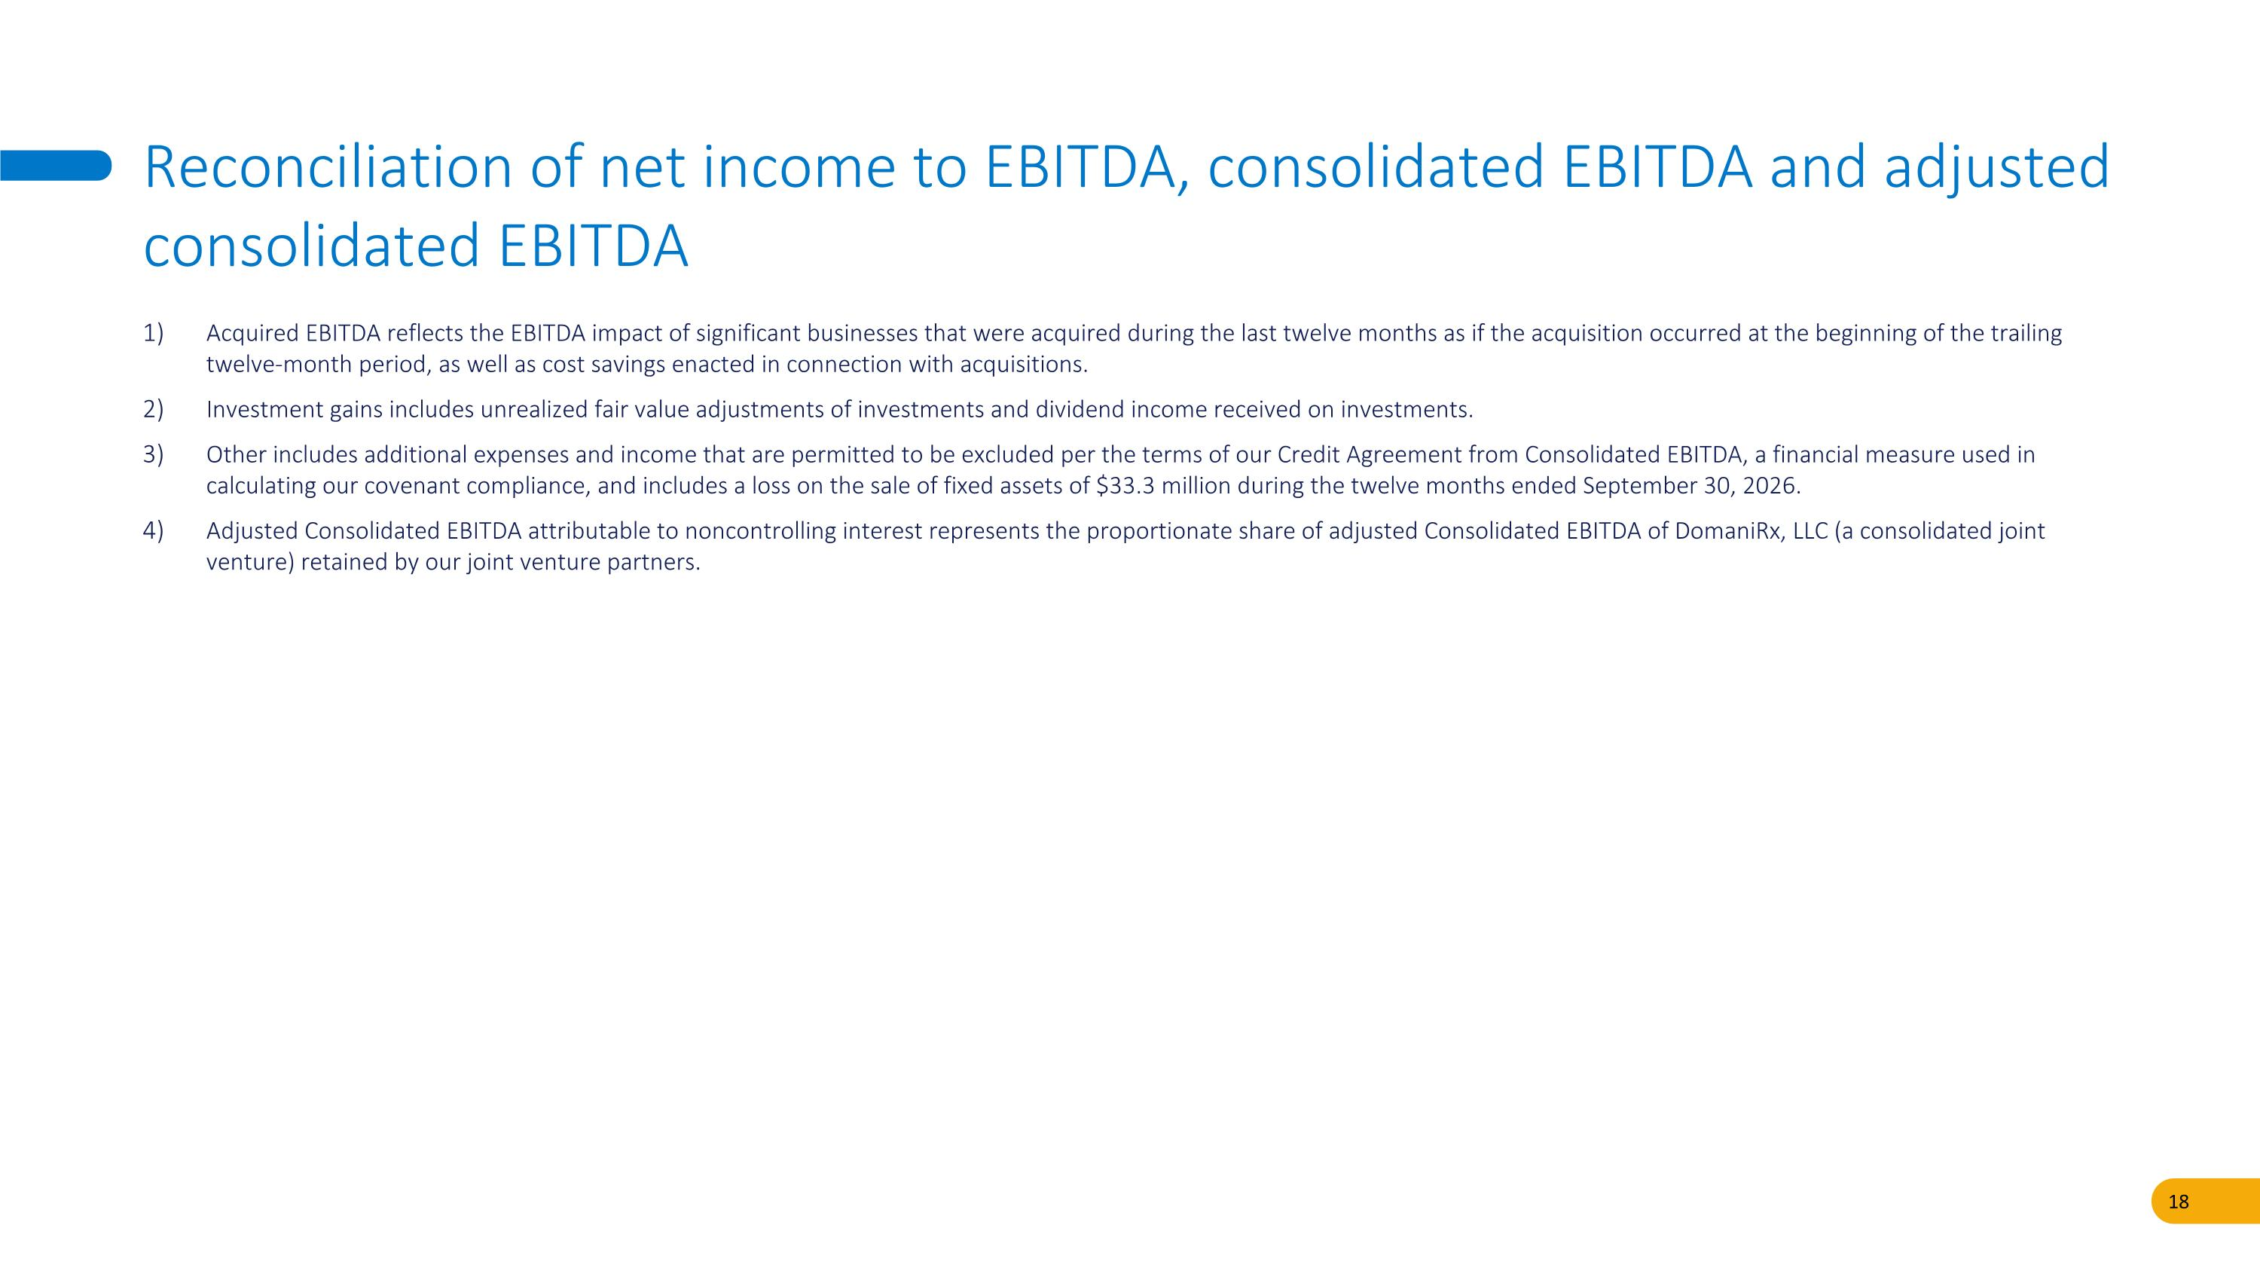
Acquired EBITDA reflects the EBITDA impact of significant businesses that were acquired during the last twelve months as if the acquisition occurred at the beginning of the trailing twelve-month period, as well as cost savings enacted in connection with acquisitions. Investment gains includes unrealized fair value adjustments of investments and dividend income received on investments. Other includes additional expenses and income that are permitted to be excluded per the terms of our Credit Agreement from Consolidated EBITDA, a financial measure used in calculating our covenant compliance, and includes a loss on the sale of fixed assets of $33.3 million during the twelve months ended September 30, 2026. Adjusted Consolidated EBITDA attributable to noncontrolling interest represents the proportionate share of adjusted Consolidated EBITDA of DomaniRx, LLC (a consolidated joint venture) retained by our joint venture partners. Reconciliation of net income to EBITDA, consolidated EBITDA and adjusted consolidated EBITDA

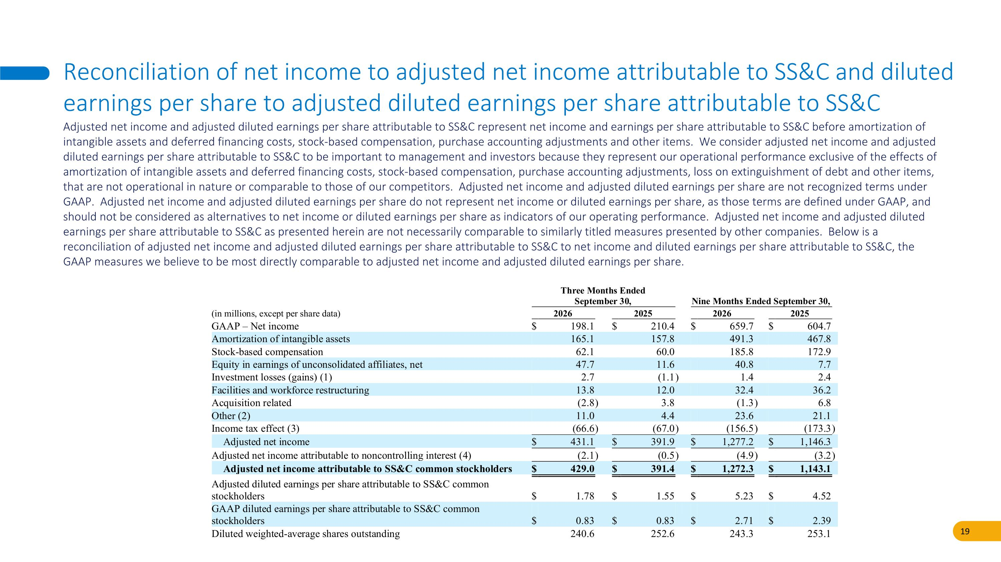
Adjusted net income and adjusted diluted earnings per share attributable to SS&C represent net income and earnings per share attributable to SS&C before amortization of intangible assets and deferred financing costs, stock-based compensation, purchase accounting adjustments and other items. We consider adjusted net income and adjusted diluted earnings per share attributable to SS&C to be important to management and investors because they represent our operational performance exclusive of the effects of amortization of intangible assets and deferred financing costs, stock-based compensation, purchase accounting adjustments, loss on extinguishment of debt and other items, that are not operational in nature or comparable to those of our competitors. Adjusted net income and adjusted diluted earnings per share are not recognized terms under GAAP. Adjusted net income and adjusted diluted earnings per share do not represent net income or diluted earnings per share, as those terms are defined under GAAP, and should not be considered as alternatives to net income or diluted earnings per share as indicators of our operating performance. Adjusted net income and adjusted diluted earnings per share attributable to SS&C as presented herein are not necessarily comparable to similarly titled measures presented by other companies. Below is a reconciliation of adjusted net income and adjusted diluted earnings per share attributable to SS&C to net income and diluted earnings per share attributable to SS&C, the GAAP measures we believe to be most directly comparable to adjusted net income and adjusted diluted earnings per share. Reconciliation of net income to adjusted net income attributable to SS&C and diluted earnings per share to adjusted diluted earnings per share attributable to SS&C

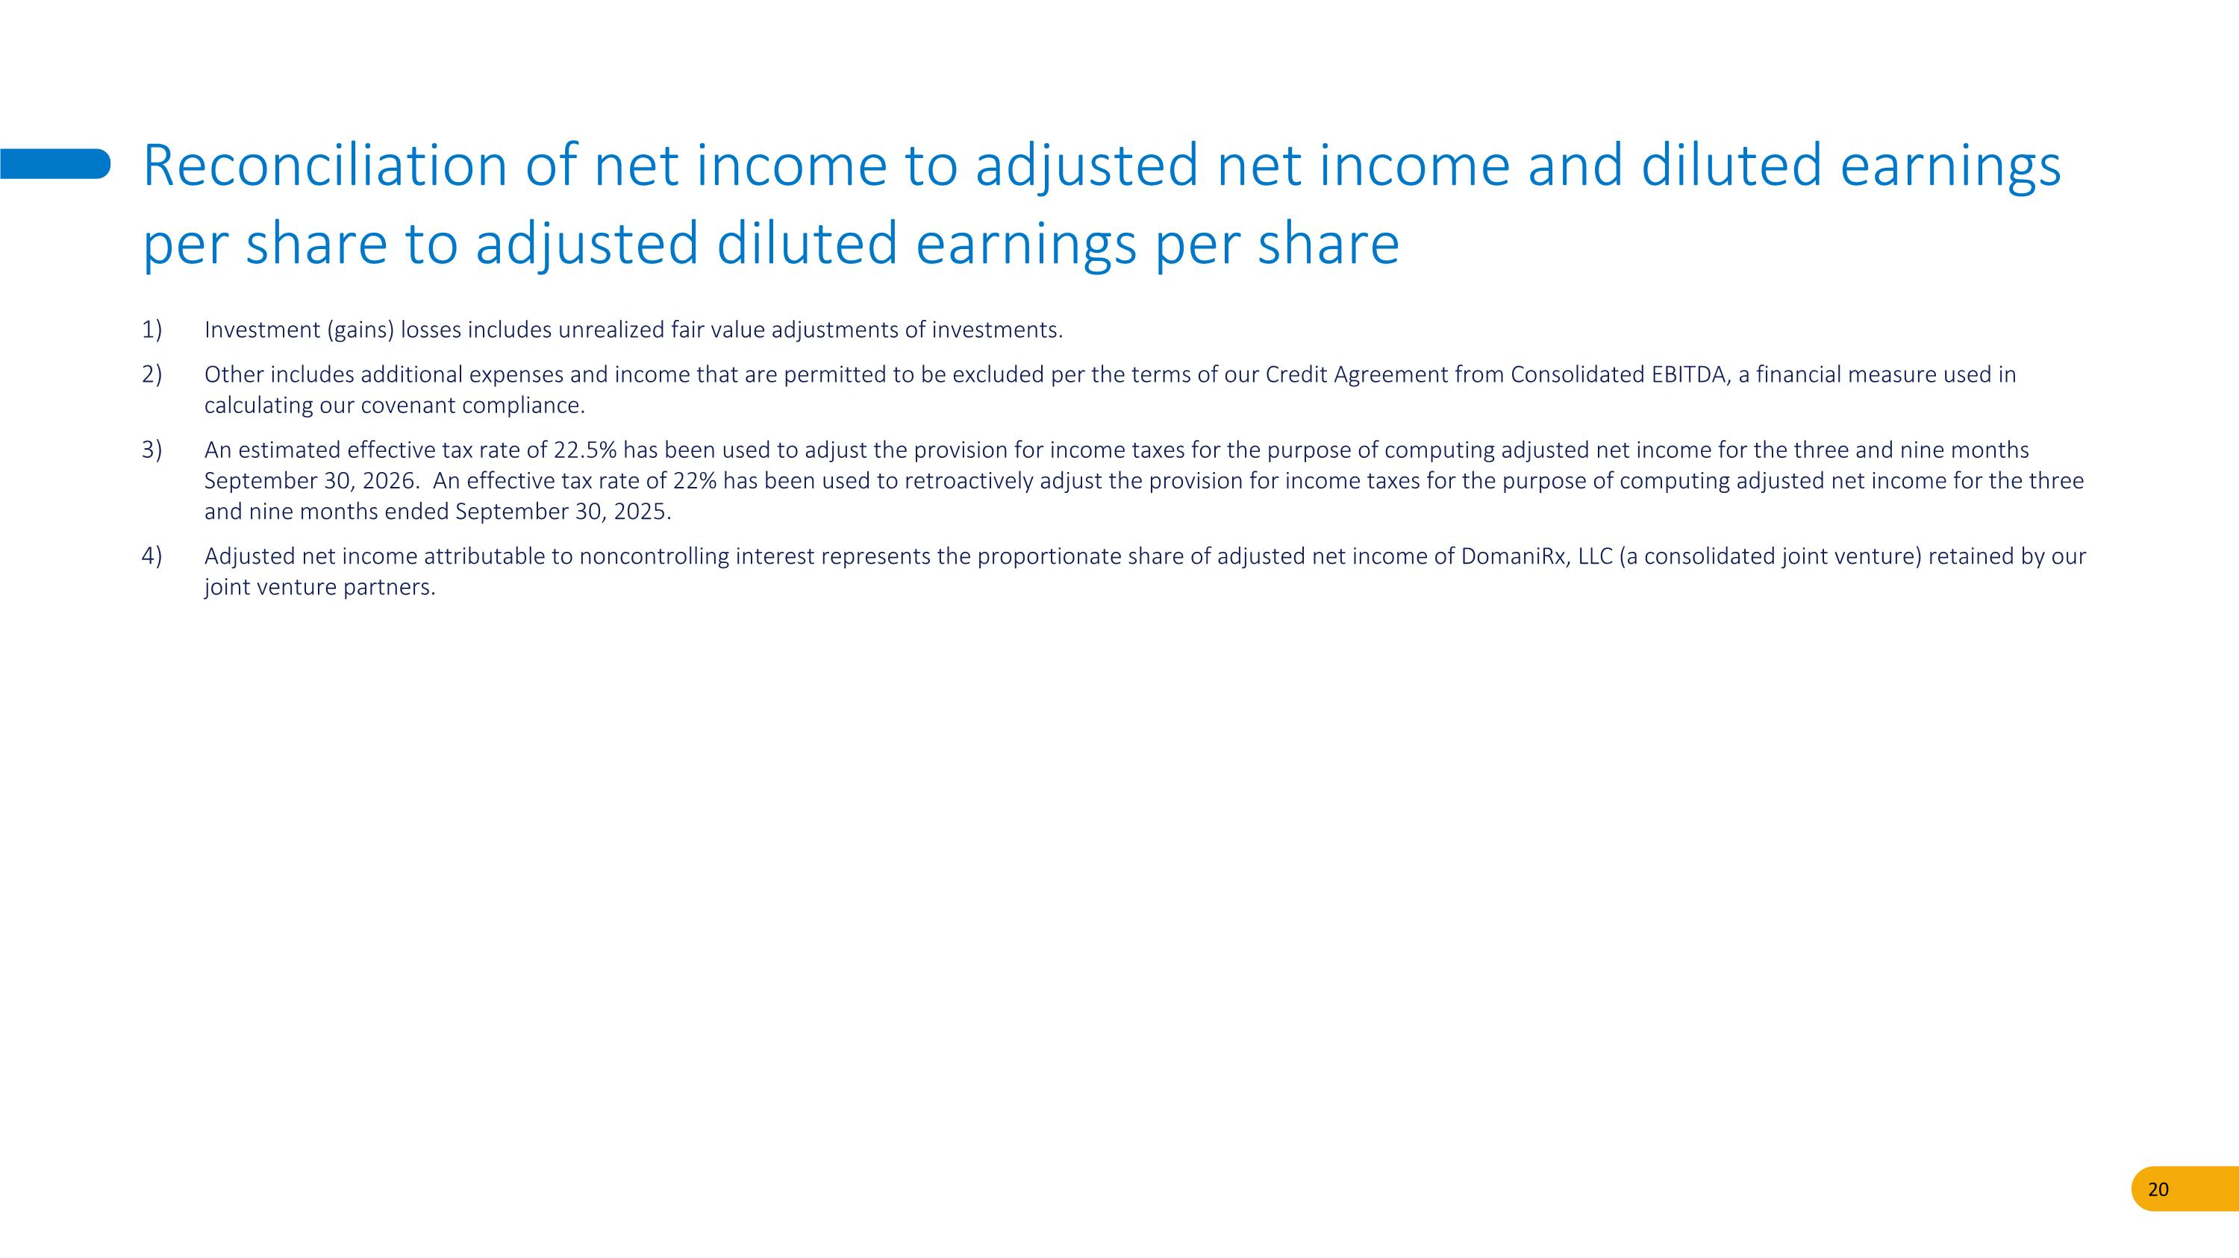
Investment (gains) losses includes unrealized fair value adjustments of investments. Other includes additional expenses and income that are permitted to be excluded per the terms of our Credit Agreement from Consolidated EBITDA, a financial measure used in calculating our covenant compliance. An estimated effective tax rate of 22.5% has been used to adjust the provision for income taxes for the purpose of computing adjusted net income for the three and nine months September 30, 2026. An effective tax rate of 22% has been used to retroactively adjust the provision for income taxes for the purpose of computing adjusted net income for the three and nine months ended September 30, 2025. Adjusted net income attributable to noncontrolling interest represents the proportionate share of adjusted net income of DomaniRx, LLC (a consolidated joint venture) retained by our joint venture partners. Reconciliation of net income to adjusted net income and diluted earnings per share to adjusted diluted earnings per share


THANK YOU. © SS&C Technologies, Inc.

